Procurement Management Portal
ABC Tech.

Epics
User Stories with Acceptance Criteria
Validation Sheets
&
Wireframes

Table of Contents

Table of Contents 2
Epics 4
E01.1 User Authentication 4
E01.2 Request Management 4
E02 Dashboard & Status Tracking for Leads & Managers 4
E03. Warehouse Team Module 4
E04. Purchase Team Module 4
E05. Accounts Team Module 4
E06. System-Level Epics 4
User Stories: 5
E01.1 User Authentication 5
US-E01.1.1 Login 5
US-E01.1.2 Registration 6
US-E01.1.3a – Password Reset Request 8
US-E01.1.3b – Password Reset Completion 9
US-E01.1.4 Logout 12
US-E01.1.5 Receive / View portal notifications. 14
E01.2 Request Management 15
US-E01.2.1 Create new hardware procurement requests (All Employees) 15
US-E01.2.2 View hardware procurement requests (All Employees) 17
US-E01.2.3 Modify, or Cancel hardware procurement requests (All Employees) 19
E02 Approvals for Leads & Managers 20
US-E02.1.0 View, Approve /Reject Request (Leads & Managers) 20
E03. Warehouse Team Module 22
E03.1 View Requests & Inventory Check 22
E03.2 GRN Preparation 24
E04. Purchase Team Module 29
E04.1a View RFQs 29
E04.1b Issue / Create RFQs 31
E04.2a View Vendor Quotes 36
E04.2b Compare Vendor Quotes 37
E04.2c Receive Vendor Quotes 40
E04.3 View POs 43
E04.3 Create and Send PO 46
E05. Accounts Team Module 50
E05.1 3-Way Matching 50
E05.2 Payment Status Update 54
E06. System-Level Epics 57
US-E06.1a Generate Alerts & Notifications 57
US-E06.1b View Alerts & Notifications (Portal) 57
E06.2 Role-Based Access Control (RBAC) 58

Epics

E01.1 User Authentication
- Login
- Registration
- Password Reset
- Logout

E01.2 Request Management
- Create
- View
- Modify
- Cancel Requests

E02 Dashboard & Status Tracking for Leads & Managers
- View, Approve /Reject Request

E03. Warehouse Team Module
- View Requests & Inventory Check
- GRN Preparation
- Dispatch / Fulfilment Confirmation
- Route to Purchase

E04. Purchase Team Module
- View RFQs
- Issue RFQs
- Receive & Manage Vendor Quotes
- Compare Vendor Quotes
- View, Create and Send PO

E05. Accounts Team Module
- 3-Way Matching
- Payment Status Update

E06. System-Level Epics
- Alerts & Notifications
- Role-Based Access Control (RBAC)

User Stories:

E01.1 User Authentication

US-E01.1.1 Login
User Story Statement:
As a registered employee,
I want to log into the Procurement Management Portal (PMP),
so that I will be able to use the portal services.

Acceptance Criteria:
- User must enter a valid email & password to log in.
- If the login credentials are valid then the user should be redirected to the dashboard.
- If login credentials are invalid then error message should be displayed.
- If the user is not registered then the user should be prompted to register.
- The password should always be masked by default (dots or asterisks).
- A ‘Forgot Password’ link should be displayed for the user to reset the password.
- A ‘Register’ link should be displayed for a new user to sign up.

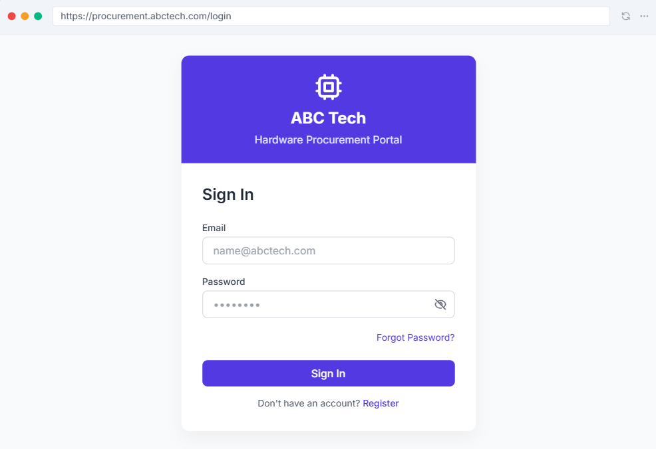

US-E01.1.2 Registration
User Story Statement:
As an unregistered employee,
I want to register myself on the Procurement Management Portal (PMP),
so that I will be able to use the portal services.

Acceptance Criteria:
- User must be able to access the Registration page via a visible "Register" link on the login screen.
- User must provide the following mandatory information:
  - Full Name
  - Official Email Address (must be unique and valid)
  - Designation / Department (from dropdown)
  - Contact Number
  - Password & Confirm Password
- Password must meet security criteria (e.g., min 8 characters, one number, one capital letter).
- Confirm Password must match exactly with Password.
- Email address must be validated for correct format (e.g., user@abctech.com).
- Email must not already exist in the system.
- Upon successful registration:
  - A success message is displayed ("Registration successful. Please log in.")
  - The user is redirected to the Login page.
- If any mandatory field is missing or invalid, an inline error message should be shown next to the field.
- If registration fails an error message should be shown.

Wireframe:
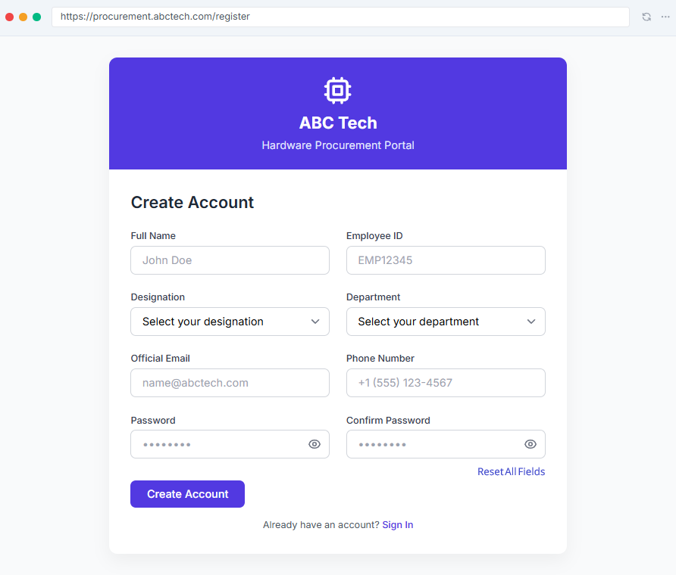

Validation Sheet:

Field Name | Data Type | Mandatory? (Y/N) | Editable? (Y/N) | Default Value | Validation Rules / Format | Max Length | Error Message | Remarks | Example Values
Full Name | Text | Y | Y | — | Alphabets and space only | 100 | Please enter a valid name | Free text input | John Deer
Official Email | Text | Y | Y | — | Must end with "@abctech.com", valid format | 100 | Please enter a valid email address | Used for login and communication | john.deer@abctech.com
Employee ID | Alpha-Numeric | Y | Y | — | Alphanumeric, no special characters | 8 | Please enter a valid Employee ID | Must be unique | EID12345
Department | Text (Dropdown) | Y | N | "Select Department" | Value must exist in department master | 50 | Please select a valid department | Pulled from master list (e.g., IT, Finance) | IT Operations
Designation | Text (Dropdown) | Y | N | "Select Designation" | Value must exist in designation list | 50 | Please select a valid designation | Predefined based on department | Manager
Password | Text (masked) | Y | Y | — | Min 8 characters, 1 number, 1 special character | 50 | Password must meet the minimum criteria | Masked input | ********
Confirm Password | Text (masked) | Y | Y | — | Must match exactly with Password | 50 | Passwords do not match | Masked input | ********

US-E01.1.3a – Password Reset Request
User Story Statement:
As a registered employee,
I want to request a password reset,
so that I can regain access to the Procurement Management Portal.
Acceptance Criteria:
- User must be able to access the Password Reset page via a visible "Forgot Password" link on the login screen.
- User must enter a valid registered email ID to initiate the request.
- Upon successful validation:
  - A password reset link is sent to the registered email address.
  - A confirmation message is displayed:
“Password reset request submitted successfully. Kindly check your email to continue.”
- The reset link should:
  - Be valid for 1 hour only.
  - Expire automatically after 1 hour or once used.
- If the link is invalid/expired:
  - A message is shown:
“The link you are trying to access is invalid or has expired. Please try again.”
  - User is redirected to the login page.
- If the user cancels the reset process, they are redirected back to the login page.

Wireframe
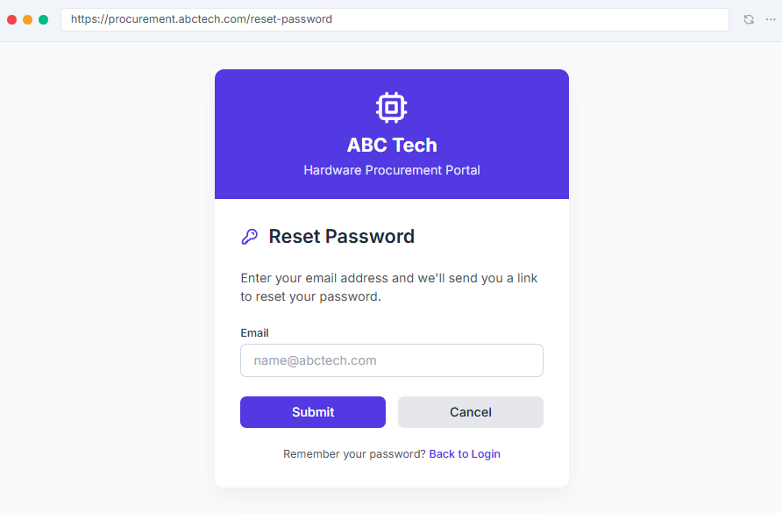

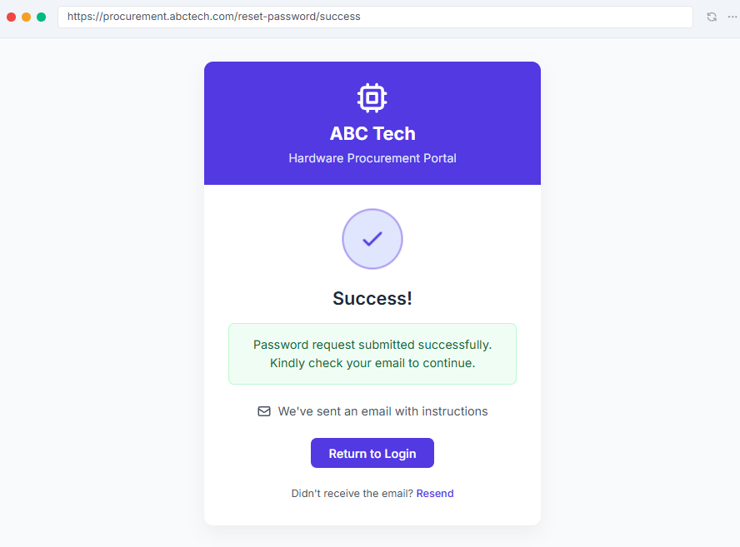

US-E01.1.3b – Password Reset Completion
User Story Statement:
As a registered employee,
I want to set a new password using the reset link,
so that I can securely log in to the portal again.
Acceptance Criteria:
- When the user clicks the link from the reset email:
  - They are redirected to the New Password page.
- User must enter:
  - A new password
  - A confirm password field that matches the new password
- Password must meet security criteria:
  - Minimum 8 characters
  - Must include at least 1 uppercase letter, 1 lowercase letter, 1 number, and 1 special character
- If passwords do not match, an inline error is shown:
“Passwords do not match.”
- If password does not meet security requirements:
“Password does not meet security criteria.”
- On successful reset:
  - A message is displayed:
“Password successfully reset. Please log in again.”
  - User is redirected to the login page
  - A confirmation email is sent to the user
  - The database is updated with the new password hash
- If the reset fails (e.g., DB error or expired token):
  - An error message is shown:
“Something went wrong. Please try again.”
- If the user cancels the reset midway, they are redirected to the login page.

Wireframe
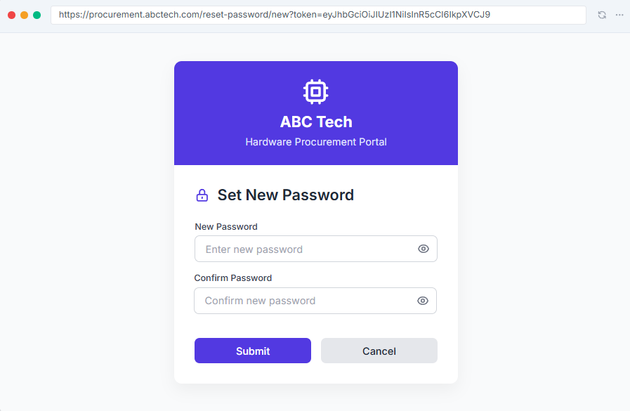
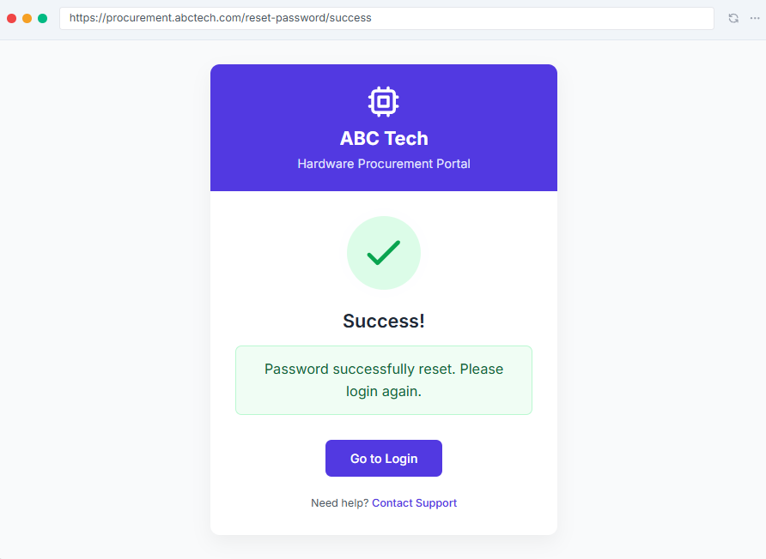

US-E01.1.4 Logout
User Story Statement:
As a logged-in user,
I want to log out of the portal,
so that I can securely terminate my session.
Acceptance Criteria:
- A logout option is accessible from the profile icon in the portal header, and is visible on every screen.
- When the user selects Logout, a confirmation dialog appears with the message:
  - “Are you sure you want to log out?”
  - And two options: “Yes” and “Cancel”.
- If the user selects Cancel, the dialog is closed and they remain on the current screen.
- If the user selects Yes:
  - The session is securely terminated (server-side and client-side).
  - The user is redirected to the login screen.
  - A message is shown:
“You have successfully logged out of the Procurement Management Portal.”
With a “Sign In” button.
- If the logout action fails due to any issue or session timeout, the user is shown an error message:
“Something went wrong. Please try again.”

Wireframes:
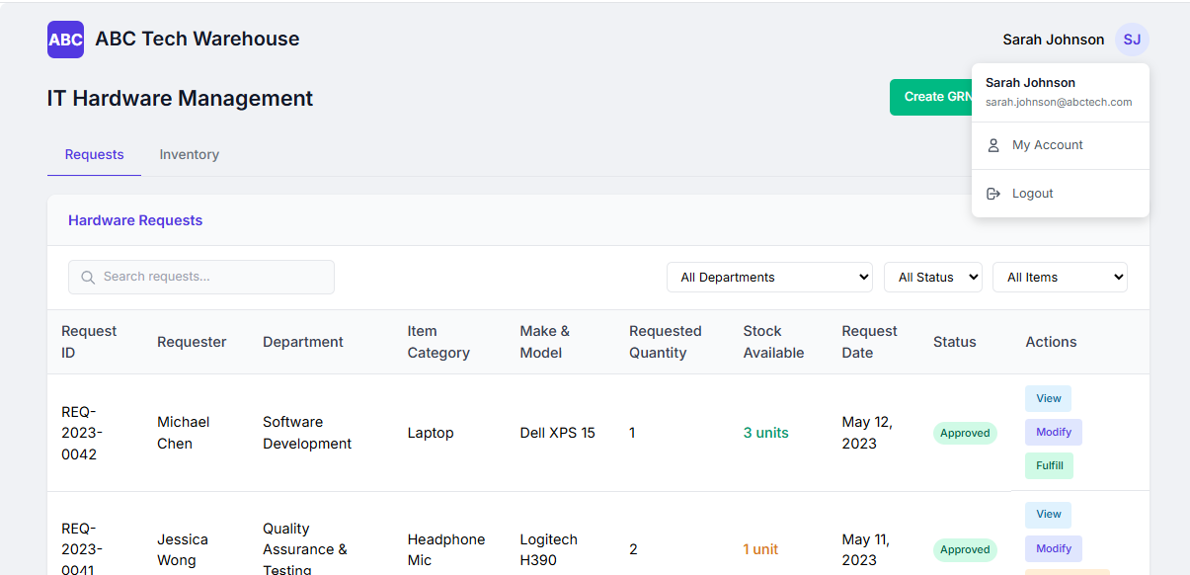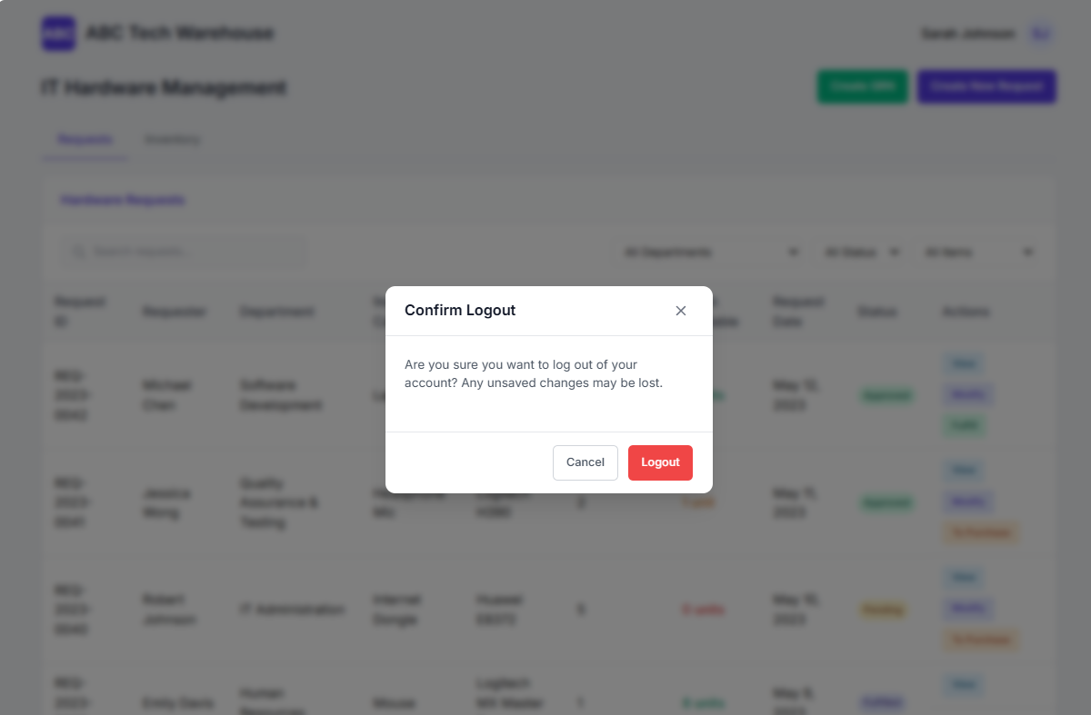

US-E01.1.5 Receive / View portal notifications.
User Story Statement:
As a logged-in user,
I want to view notification on the Portal,
so that I can keep track of activities and updates related to Hardware Procurements Requests.
Acceptance Criteria:
- A Notification option/bell icon is accessible on the portal header, and is visible on every screen.
- The notification screen contains two tabs:
  - All Notifications
  - Unread Notifications
- Each notification shows
  - Title
  - Notification summary text
  - Request ID
  - A “View Request” button to view the request in detail.
- A “Mark All as Read” button is available for quick actions.
- When user clicks View Request button, they are able to view the request in detail.
- The user can perform bulk actions by selecting multiple notifications using checkboxes to
  - Mark as Read the selected notifications
  - Delete the selected notifications
- If there are no notifications, a message should be displayed
“No notifications at the moment.”

Wireframe:
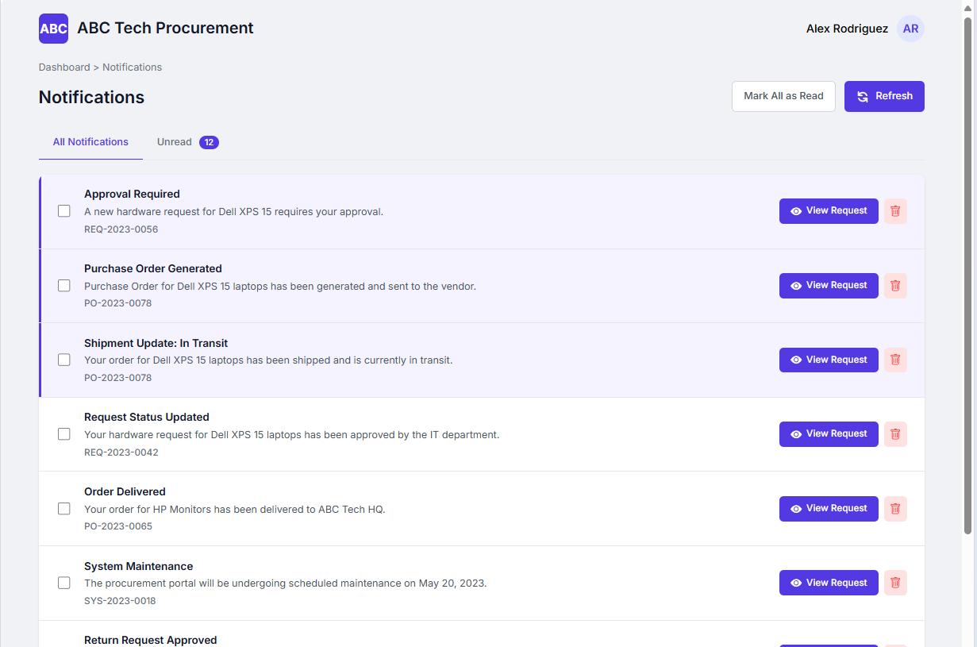

E01.2 Request Management

US-E01.2.1 Create new hardware procurement requests (All Employees)
User Story Statement:
As a logged-in employee,
I want create a new hardware request from the dashboard,
so that I can initiate a formal request for equipment I need to perform my work.
Acceptance Criteria:
- After a successful login, the user is redirected to the dashboard.
- User is able to generate a new request by clicking the “Create New Request” button
- When user clicks “Create New Request” button, a new Hardware Request form opens and the user is able to enter the following details;
  - Employee Name
  - Employee ID
  - Department
  - Designation
  - Hardware Category
  - Hardware Make
  - Hardware Model
  - Quantity
  - Justification
  - Urgency
  - Additional Notes
- Inputs for the following fields are auto-generated by the system
  - Request ID
  - Request Date
  - Status
  - Unit Price
  - Total Price
- The input data is validated (as per rules in the validation sheet) and inline error message is displayed if any errors.
- Default status “Draft” is assigned before submission.
- Upon successful validation, when user submits the request,
  - The request to forwarded to the Led if Total Amount <= Rs. 5000/- else
  - The request to forwarded to the Manager if Total Amount > Rs. 5000/-
  - Status is changed from “Draft” to “Submitted”
- A message is displayed
“Your request has been successfully submitted. Thank you.”
- If the process fails due to any issue or session timeout, the user is shown an error message:
“Something went wrong. Please try again.”
Wireframe:
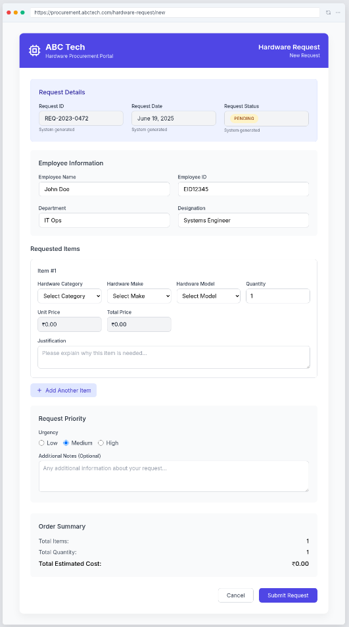

US-E01.2.2 View hardware procurement requests (All Employees)
User Story Statement:
As a logged-in employee,
I want to view the status of my submitted hardware procurement requests on the dashboard,
so that I can track progress without needing to follow up manually.
Acceptance Criteria:
- After a successful login, the user is redirected to the dashboard.
- The dashboard displays a table of all previous requests raised by the logged-in user.
- The requests table includes the following columns:
  - Sr. No.
  - Request ID
  - Request Date
  - Items Requested (short description or item count)
  - Estimated Amount
  - Current Status (e.g., Draft, Approved, Routed to Purchase, Delivered)
- The user is able to click on a specific request to view its full details.
- A filter dropdown is available to filter requests by:
  - All
  - Draft
  - Submitted
  - Approved
  - Fulfilled / Closed
  - Cancelled / Deleted
- The table should be sorted by date descending by default (most recent requests at the top).
- Pagination functionality should be enabled for large no of requests.
Wireframe:
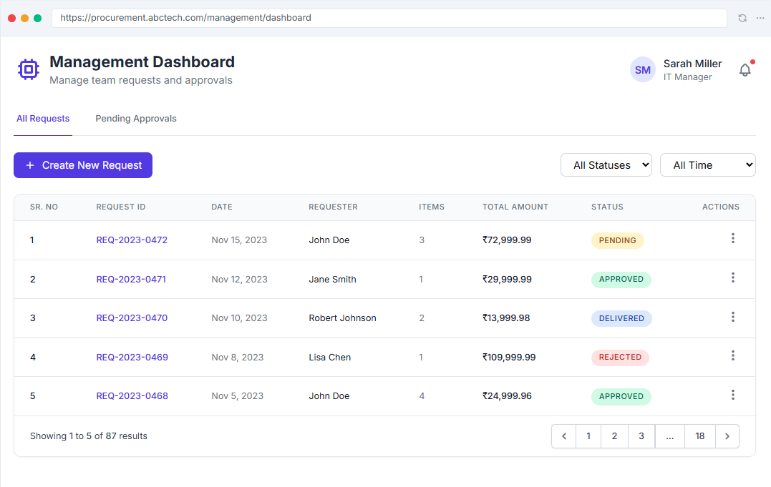

US-E01.2.3 Modify, or Cancel hardware procurement requests (All Employees)
User Story Statement:
As a logged-in user,
I want to modify or delete my hardware procurement request from the dashboard,
so that I can correct errors or cancel any of my requests if no longer required.
Acceptance Criteria:
- Upon login, the user is redirected to the dashboard.
- The dashboard must display a list/table of all requests raised by the logged-in user.
- Each request row should allow the user to:
  - View request details (always enabled)
  - Modify the request (only if it has not yet been approved by the TL/Manager)
  - Delete the request (only if it has not yet been approved)
- If the request has been approved, the edit/delete options should be disabled or hidden.
- A confirmation dialog should be shown before deletion:
“Are you sure you want to delete this request? This action cannot be undone.”
- Upon successful deletion or modification, a success message is shown and the dashboard table is refreshed.

Wireframe:
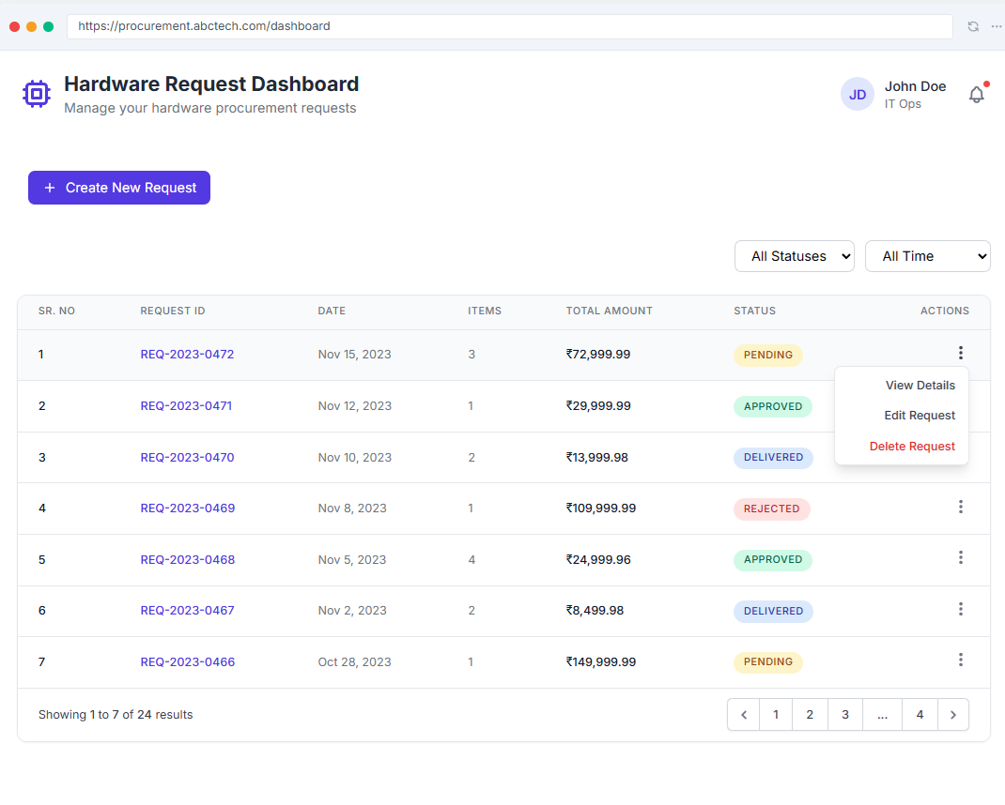

E02 Approvals for Leads & Managers

US-E02.1.0 View, Approve /Reject Request (Leads & Managers)
User Story Statement:
As a logged-in Lead,
I want to view hardware procurement requests submitted for my approval on the dashboard,
so that I can view, approve or reject the requests.
Acceptance Criteria:
- After a successful login, the user is redirected to the dashboard.
- “Approvals” tab is displayed showing the table of all the requests routed to the user for approval.
- The requests table includes the following columns:
  - Sr. No.
  - Request ID
  - Request Date
  - Items Requested (short description or item count)
  - Estimated Amount
  - Current Status (e.g., Submitted, Approved, Routed to Purchase, Delivered)
  - Action (Action buttons/options for following )
    - View Request
    - Approve Request
    - Reject Request
- The user is able to view the full form by clicking the “View”.
- When the user selects “Approve”
  - Request status is updated to “Approved”
  - A notification is sent to the Requester & the Warehouse Team.
- When the user selects “Rejected”
  - Request status is updated to “Rejected”
  - A notification is sent to the Requester & the Warehouse Team.
- The user is able to click on a specific request to view its full details.
- A filter dropdown is available to filter requests by:
  - All
  - Submitted
  - Approved
  - Rejected
  - Fulfilled / Closed
  - Cancelled
- The table should be sorted by date descending by default (most recent requests at the top).
- Pagination functionality should be enabled for large no of requests.

Wireframe:
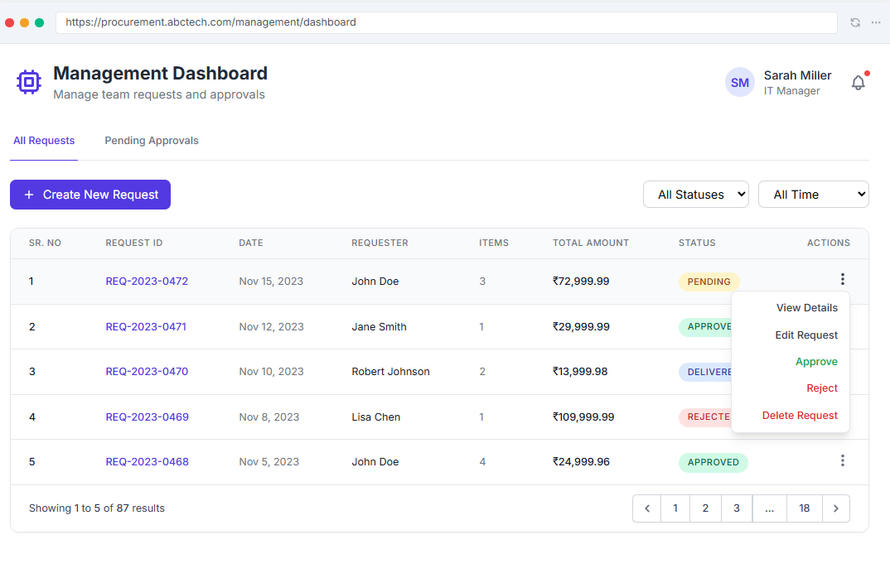

E03. Warehouse Team Module

E03.1 View Requests & Inventory Check
- Check availability of requested hardware items.
Story Statement:
As a logged-in user from warehouse team,
I want to view the approved hardware procurement requests on the dashboard,
so that I can view, fulfil if stock available or forward the request to purchase if stock unavailable.
Acceptance Criteria:
- After a successful login, the user is redirected to the dashboard.
- A table of approved requests is visible to the user with following
  - Request ID,
  - Item Name
  - Quantity Requested,
  - Requested By,
  - Department,
  - Data
  - Stock Availability
  - Status
  - Action button to view request
- When user clicks “view request” button a sliding panel displays the full details and options to
  - Fulfil From Stock (if stock is available)
  - Route the request to Purchase team (if stock is not available)
- When user clicks “Fulfil from Stock”,
  - The items are handed over to the requester.
  - A notification is sent to the requester
  - Stock entry update is pushed to the Tally Prime via API call to update the Inventory.
- If stock data cannot be retrieved (e.g., Tally not connected), the column displays a fallback message:
“Inventory check unavailable – please verify manually in Tally.”
Wireframes:
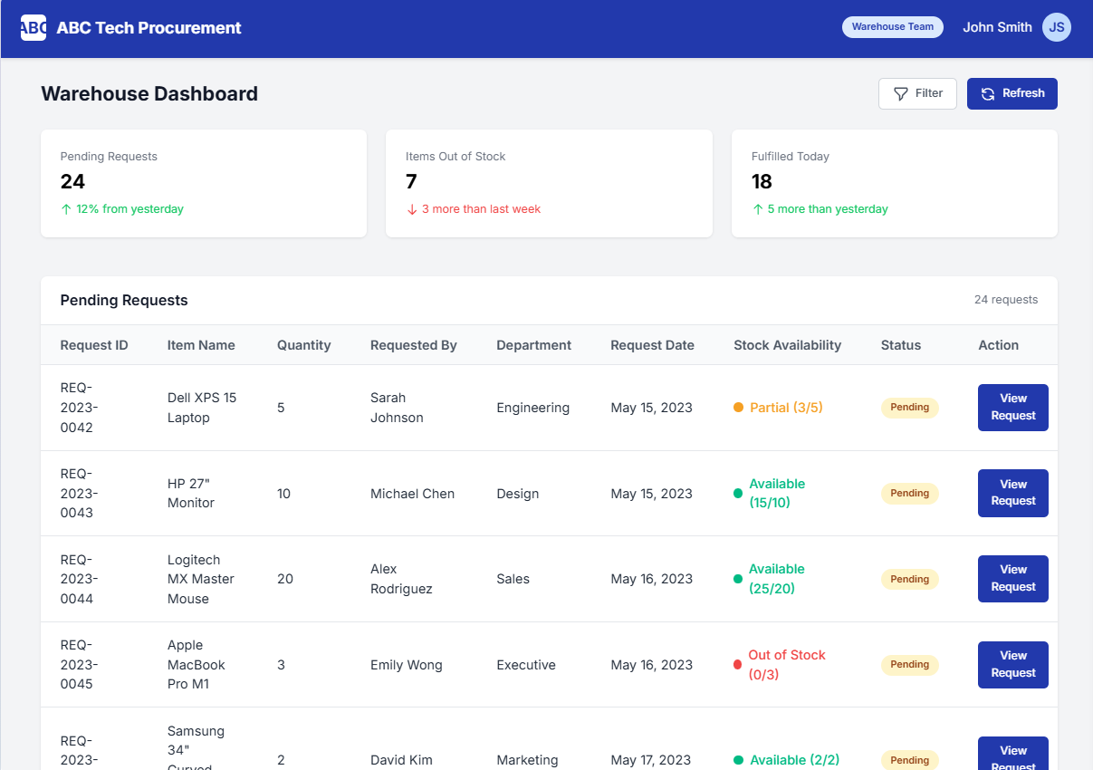

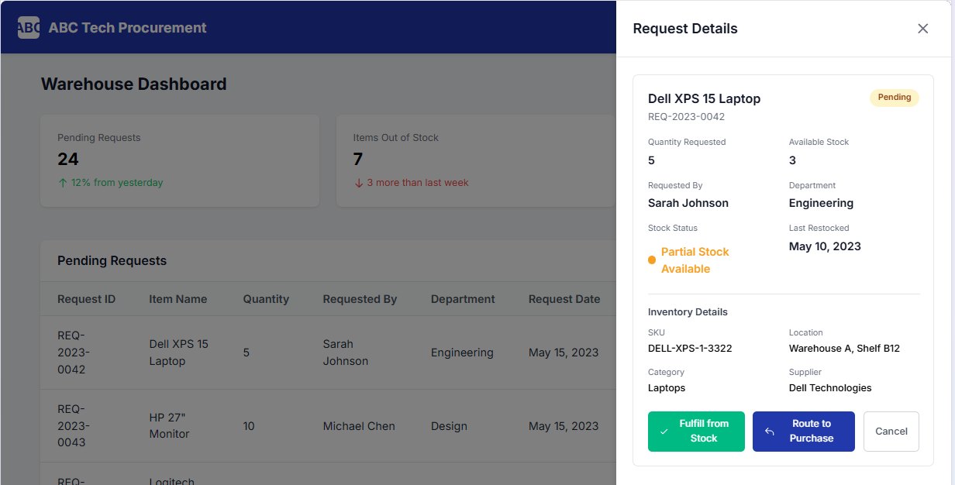

E03.2 GRN Preparation
- Generate Goods Received Note based on receipt and inspection.
Story Statement:
As a logged-in user from warehouse team,
I want to create a GRN from the dashboard,
so that I can receive and update the stock in the inventory.
Acceptance Criteria:
- After a successful login, the user is redirected to the dashboard.
- A “Create GRN” button is visible on the dashboard.
- When user clicks “Create GRN”, a new form opens up with
  - Auto-filled System-generated Fields
    - GRN ID
    - PO / Order No
    - Date
    - Vendor
    - Delivery Location
    - Ordered Quantity
  - Manual User input fields for
    - Goods
    - Size
    - Quantity Received
    - Comments
    - Received By
    - Checked By
    - Additional Notes
- The system validated the input data (as per the validate sheet attached) and displays inline message if any errors.
- User can upload the supporting documents in (PDF/PNG/JPEG/Excel/Word/CSV format).
- Upon successful submission:
  - A GRN is created
  - A notification is sent to the Purchase & Accounts Team along with the copy of the GRN.
  - The GRN is pushed to the TallyPrime (via API/connector or exported)
- If GRN submission fails (e.g., integration issue), an error message is shown:
“Unable to sync GRN with Tally. Please try again or notify IT support.”

Validation Sheet
Field Name | Data Type | Mandatory? | Editable? | Default Value | Validation Rules / Format | Max Length | Error Message | Remarks | Example Values
GRN ID | Numeric | Y | N | Auto-filled | Numerical, auto-incremented | 100 | NA | NA | 1
PO / Order No | Alpha-Numeric | Y | N | System generated | Auto-generated (UUID or sequence) | 20 | NA | Pulled from request | PMP-RQ-2025-001
Date | Date | Y | N | NA | System Date | NA | NA | Pulled from request | #######
Vendor | Text | Y | N | NA | Valid Item from Inventory | 50 | NA | Pulled from request | Sony
Delivery Location | Currency | Y | N | NA | Currency |  | NA | Pulled from request | ₹ 5,000
Sr. No | Numeric | Y | N | Auto-filled | Numerical, auto-incremented | 100 | NA | NA | 1
Goods | Text | Y | Y | NA | Text | 50 | NA |  | Microsoft Inc
Size | Numeric | N | Y | Blank | Numerical, manually added if applicable | 100 | NA | NA | 1
Quantity | Numeric | Y | Y | 1 | Numerical, manually added | 1000 | NA | NA | 44
Ordered Quantity | Numeric | Y | N | NA | Numerical, Pulled from PO | 1000 | NA | NA | 123
Comments | Text | N | Y | NA | Text | 200 | NA | Additional Info | Different colour than ordered
Received By | Text | Y | Y | NA | Text, Name of the Employee receiving the goods | 200 | NA |  | John Deer
Checked By | Text | Y | Y | NA | Text, Name of the Employee inspecting the goods | 200 | NA |  | John Deer
Notes | Text | N | Y | NA | Text | 200 | NA | Additional Info | Delayed shipment

Wireframe
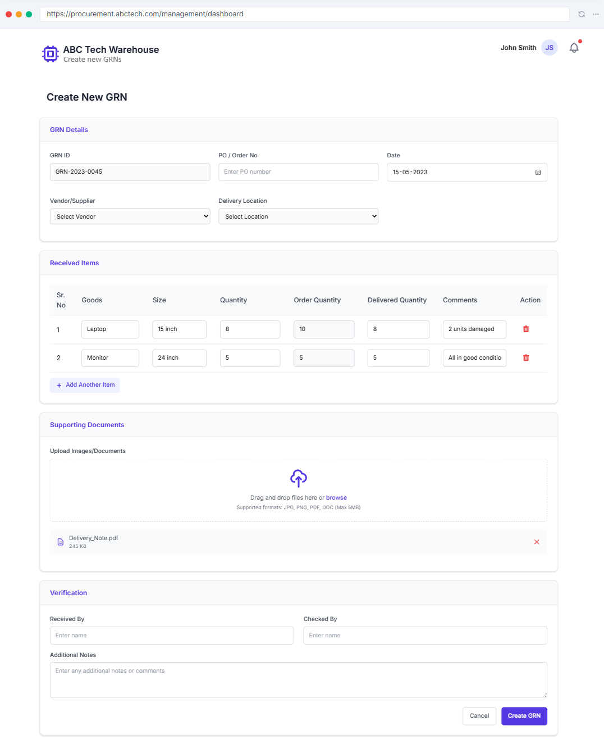



E04. Purchase Team Module

E04.1a View RFQs
- Create and send Request for Quotation (RFQ) to vendors.
User Story Statement:
As a logged-in user from purchase team,
I want to create and send RFQ from the dashboard,
so that I will be able to receive quotations from the vendors.
Acceptance Criteria:
- After a successful login, user is redirected to the dashboard.
- The dashboard includes a dedicated “RFQs” tab or section.
- The RFQs Table includes the following columns:
  - Sr. No.
  - RFQ No. (auto-generated, e.g., ABC/PMP/RFQ/2025/001)
  - Date of Issue
  - Item Summary (brief line showing item names or count)
  - Last Date for Submission
  - Status (Draft / Sent / Closed / Cancelled)
  - Action: View / Edit / Send
- The table should be sorted by date descending by default (most recent requests at the top).
- Pagination functionality should be enabled for large no of RFQs.
- Clicking “View Details” the full RFQ form.
- If no RFQs exist, display a friendly message:
“No RFQs created yet. Click ‘Create RFQ’ to start.”
Validation Sheet:
Field Name | Data Type | Mandatory? | Editable? | Default Value | Validation Rules / Format | Max Length | Error Message | Remarks | Example Values
Sr. No. | Numeric | Y | N | Auto-filled | Numerical, auto-inceremented | 100 | NA | NA | 1
RFQ No | Alpha-Numeric | Y | N | System generated | Auto-generated (UUID or sequence) | 20 | NA | Pulled from request | PMP-RQ-2025-001
Date of Issue | Date | Y | Y | NA | System Date | NA | NA | Pulled from request | 19-06-2025
Items Summary Line | Text | Y | Y | NA | Valid Item from Inventory | 50 | NA | Pulled from request | Sony
Last Date for Submission | Date | Y | Y | NA | System Date | NA | NA | Final Cutoff date | 19-06-2025
Contact Person | Text | Y | Y | NA | Valid Item from Inventory | 100 | Please add a contact person |  | John Deer
Email | Alpha-Numeric with special char | Y | Y | purchase@abctech.com | Valid company email address | 100 | Please enter a valid email id | For further communication | enzo@abctech.com
Phone | Numeric | Y | Y | 111-7894561230 | Valid company phone no | 10 | Please enter a valid phone no | For further communication | +91 9876543210
Item | Text | Y | Y | NA | From dorpdown | 100 | Please select an Item | Pulled from Inventory | John Deer
Make / Model | Text | Y | Y | NA | From dorpdown | 100 | Please select an Item | Pulled from Inventory | John Deer
Quantity | Numeric | Y | Y | 1 | Numerical | 3 | Please enter a valid quantity | NA | 4
Unit | Text | Y | N | 1 | Numerical | 10 | NA | NA | 4
Remarks | Text | Y | N | NA | Text input | 300 |  |  | Item in assorted colours
Delivery Address | Text | Y | Y | 2, Finite Loop, LA | Text input | 300 | Please select a valid delivery address | From dropdown list | Item in assorted colours
Evaluation Criteria | Text | Y | N | NA | Text input | 300 | NA |  | Items to be checked as per XYZ standard
Terms & Conditions | Text | Y | Y | NA | Text input | 300 | Please enter T&Cs |  | Payment 50% advance
Vendor Name | Text | Y | Y | NA | Dropdown list & Text Input | 300 | Please select a vendor | Dropdown list & Text Input | Microsoft Inc
Vendor Email | Alpha-Numeric with special char | Y | Y | NA | Valid email address | 100 | Please enter a valid email id | For further communication | sam@openai.com

Wireframe:
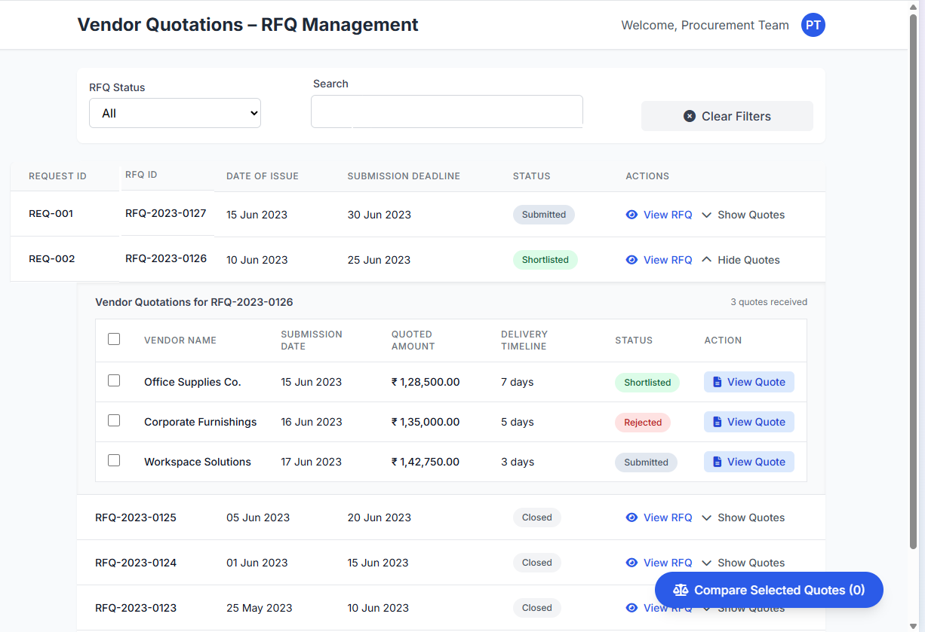

E04.1b Issue / Create RFQs
Story Statement:
As a logged-in user from purchase team,
I want to create and send RFQ from the dashboard,
so that I will be able to receive quotations from the vendors.
Acceptance Criteria:
- After a successful login, user is redirected to the dashboard.
- The dashboard includes a dedicated “Create New RFQs” Button.
- Clicking “Create New RFQs” opens up a form to create a new RFQ containing following fields
  - Company & Buyer Details
    - RFQ No. (System-generated)
    - Date (Today’s Date)
    - Email (Purchase Team member / department email)
    - Phone (Purchase Team member / department phone)
    - Delivery Address (Destination Shipping Address)
  - RFQ Purpose
  - Vendor Details
    - Vendor Name (with ability add multiple vendors)
    - Vendor Email (fetched from vendor list)
  - Item List & Specifications Table
    - Sr. No.
    - Item
    - Make / Model
    - Quantity
    - Unit
    - Remarks
  - Submission Deadline
  - Evaluation Criteria (if applicable)
  - Terms & Conditions
- The system validated the input data (as per the validate sheet attached) and displays inline message if any errors.
- Upon successful submission:
  - Confirmation message displayed
  - A RFQ is created and status is marked as “Issued”
  - A notification is sent to the Warehouse Team along with the copy of the RFQ.
  - The RFQ is automatically forwarded to the selected vendors. (Each vendor receives a separate email with the same RFQ ID)
  - The RFQ is pushed to the TallyPrime (via API/connector or exported)
- If RFQ submission fails (e.g., integration issue), an error message is shown:
“Unable to sync RFQ with Tally. Please try again or notify IT support.”
- All RFQs are logged under the “RFQs” tab for tracking and audit.

Validation Sheet
Field Name | Data Type | Mandatory? | Editable? | Default Value | Validation Rules / Format | Max Length | Error Message | Remarks | Example Values
Sr. No. | Numeric | Y | N | Auto-filled | Numerical, auto-inceremented | 100 | NA | NA | 1
RFQ No | Alpha-Numeric | Y | N | System generated | Auto-generated (UUID or sequence) | 20 | NA | Pulled from request | PMP-RQ-2025-001
Date of Issue | Date | Y | Y | NA | System Date | NA | NA | Pulled from request | 19-06-2025
Items Summary Line | Text | Y | Y | NA | Valid Item from Inventory | 50 | NA | Pulled from request | Sony
Last Date for Submission | Date | Y | Y | NA | System Date | NA | NA | Final Cutoff date | 19-06-2025
Contact Person | Text | Y | Y | NA | Valid Item from Inventory | 100 | Please add a contact person |  | John Deer
Email | Alpha-Numeric with special char | Y | Y | purchase@abctech.com | Valid company email address | 100 | Please enter a valid email id | For further communication | enzo@abctech.com
Phone | Numeric | Y | Y | 111-7894561230 | Valid company phone no | 10 | Please enter a valid phone no | For further communication | +91 9876543210
Item | Text | Y | Y | NA | From dorpdown | 100 | Please select an Item | Pulled from Inventory | John Deer
Make / Model | Text | Y | Y | NA | From dorpdown | 100 | Please select an Item | Pulled from Inventory | John Deer
Quantity | Numeric | Y | Y | 1 | Numerical | 3 | Please enter a valid quantity | NA | 4
Unit | Text | Y | N | 1 | Numerical | 10 | NA | NA | 4
Remarks | Text | Y | N | NA | Text input | 300 |  |  | Item in assorted colours
Delivery Address | Text | Y | Y | 2, Finite Loop, LA | Text input | 300 | Please select a valid delivery address | From dropdown list | Item in assorted colours
Evaluation Criteria | Text | Y | N | NA | Text input | 300 | NA |  | Items to be checked as per XYZ standard
Terms & Conditions | Text | Y | Y | NA | Text input | 300 | Please enter T&Cs |  | Payment 50% advance
Vendor Name | Text | Y | Y | NA | Dropdown list & Text Input | 300 | Please select a vendor | Dropdown list & Text Input | Microsoft Inc
Vendor Email | Alpha-Numeric with special char | Y | Y | NA | Valid email address | 100 | Please enter a valid email id | For further communication | sam@openai.com

Wireframe
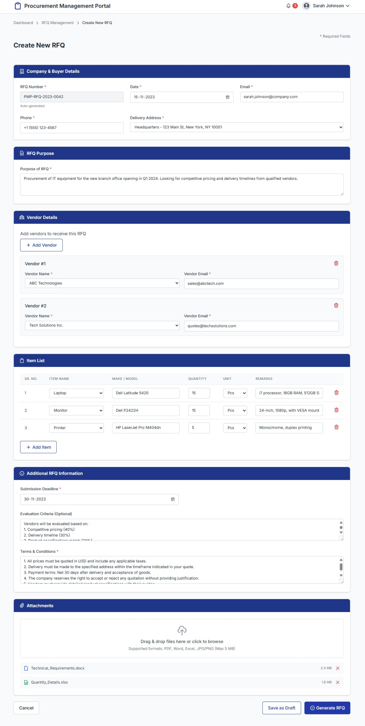

E04.2a View Vendor Quotes
- View vendor quotations received against each RFQ.
User Story Statement:
As a logged-in user from the Purchase Team,
I want to view all vendor quotations submitted for a specific RFQ from my dashboard,
so that I can review individual submissions and prepare for comparison and evaluation.
Acceptance Criteria:
- After a successful login, user is redirected to the dashboard.
- All RFQs tab displays a table for all previously issued RFQs with following columns
  - RFQ ID
  - Date of Issue
  - Submission Deadline
  - View RFQ Button
  - Actions: “Expand” (toggle)
- Expandable Section per RFQ (on toggle click)
  - A nested row appears beneath the RFQ showing all vendor quotes received under it
  - Each vendor quote row includes:
    - Checkbox (for comparison)
    - Vendor Name
    - Submission Date
    - Total Quote Amount
    - Delivery Timeline
    - Status (Submitted / Shortlisted / Rejected)
    - Action: “View Quote”
  - When user clicks “View Quote”, full quotation details form opens up where user can
    - See all the details from the quote
    - Request Revision for the quote using “Request Revision” button
    - Shortlist Vendor using “Shortlist Vendor” button
    - Reject vendor/quote using “Reject Quote” button
    - Accept vendor/quote using “Accept Quote” button
  - Table supports:
    - Pagination of RFQs
    - Filter by RFQ Status or Date Range
    - Search by RFQ ID or Vendor Name
- If no vendors responded:
“No quotations received yet for this RFQ.”

Wireframe:


E04.2b Compare Vendor Quotes
- View vendor quotations received against each RFQ.
User Story Statement:
As a logged-in user from the Purchase Team,
I want to view and compare multiple vendor quotations submitted under a specific RFQ from my dashboard,
so that I can evaluate the best option for shortlisting or procurement.
Acceptance Criteria:
- After a successful login, user is redirected to the dashboard.
- User can select multiple quotes (max 3 nos.) under a RFQ and compare using “Compare Selected Quotes”.
- When 2 or more quotes are selected, a "Compare Selected Quotes" button becomes active.
- Clicking “Compare Selected Quotes” opens a comparison table with following comparison attributes for all selected vendors
Comparison Attribute | Description
Quoted Amount | Total amount quoted (₹)
Delivery Timeline | Days or Date Range
Payment Terms | Advance, milestone-based, etc.
Tax/GST | Inclusive/Exclusive, percentage
Notes / Remarks | Any special instructions
Attached Quotation | File preview/download link
Quote Status | Submitted / Under Review / Shortlisted / Rejected
Action Buttons | Buttons for each quote column:
- Shortlist
- Reject
- Request Revision
View Quote | Opens full detail view

- User can:
  - View and evaluate all fields for up to 3 vendors
  - Perform actions (Shortlist, Reject, Request Revision) per quote directly from this screen
  - Click "View Quote" to see full original submission
  - Option to close or cancel the comparison.
Validation Sheet:
Field Name | Data Type | Mandatory? | Editable? | Default Value | Validation Rules / Format | Max Length | Error Message | Remarks | Example Values
Quoted Amount | Numerical | Y | N | NA | Currency format | 8 | NA |  | Rs. 10000
Delivery Timeline | Text | Y | N | NA | Text input | 300 | NA | Days or Date Range | 7 days from the date of PO
Payment Terms | Text | Y | N | NA | Text input | 300 | NA | Advance, milestone-based, etc. | Payment in advance
Tax/GST | Text | Y | N | NA | Text input | 300 | NA | Inclusive/Exclusive, percentage | 18% GST included
Notes / Remarks | Text | Y | N | NA | Text input | 300 | NA | Any special instructions | Free training session for IT staff.
Attached Quotation | Attachment |  | N | NA |  |  | NA | File preview/download link | TechSupply_Quote.pdf
Quote Status | Text | Y | N | NA | Text input | 50 | NA | Submitted / Under Review / Shortlisted / Rejected | Shortlisted
1. Shortlist | Action Buttons | Y | N | NA | NA | NA | NA | Quote is shortlisted
2. Reject | Action Buttons | Y | N | NA | NA | NA | NA | Quote is rejected
3. Request Revision | Action Buttons | Y | N | NA | NA | NA | NA | Quote is sent to vendor for revision
View Quote | Action Buttons | Y | N | NA | NA | NA | NA | Quote opens in full

Wireframe:
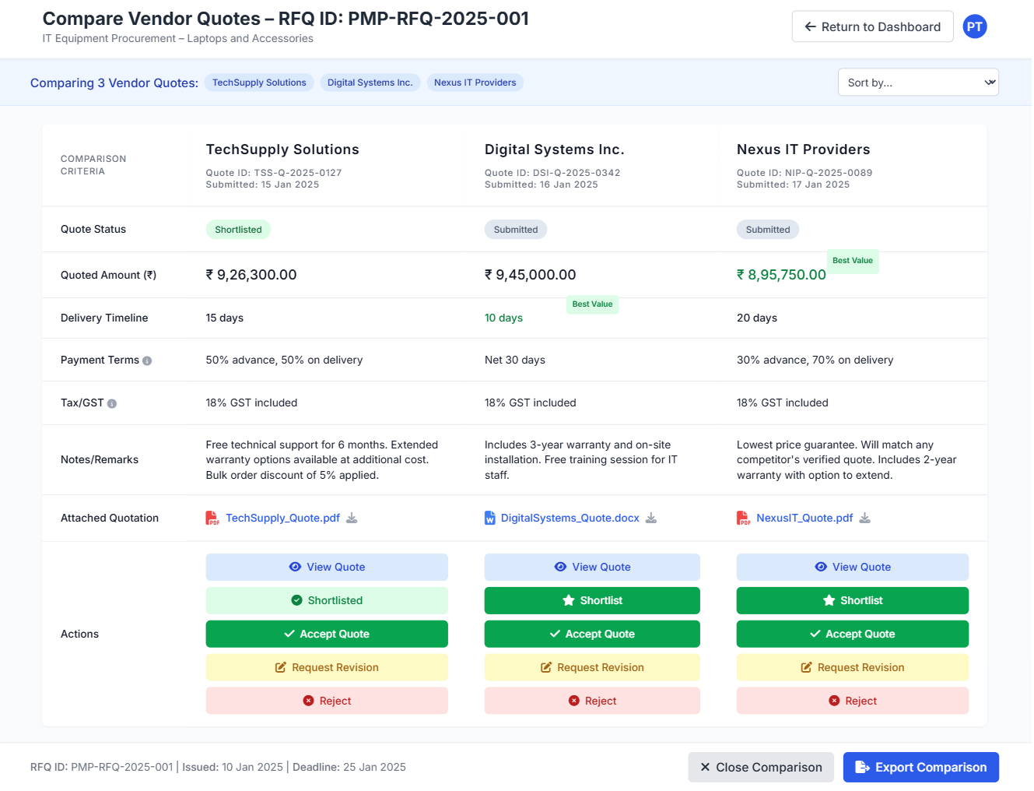

E04.2c Receive Vendor Quotes
User Story Statement:
As a logged-in user from purchase team,
I want the ability for the vendors to directly submit the quotations for the RFQ directly to the PMP,
so that I will be able to view & manage the quotes easily in one place.
Acceptance Criteria:
- After a successful login, user is redirected to the dashboard.
- After RFQ creation a tokenized link valid for the duration of date of submission is sent to each selected vendor.
- When the vendor clicks the link a Quote Submission form opens up on the portal with following fields,
  - RFQ ID
  - Date of Issue
  - Submission Deadline
  - Vendor Name
  - Vendor Email
  - Item Related Pricing Table:
    - Item Name
    - Make / Model
    - Quoted Unit Price
    - Quantity Offered
    - GST or Tax Details
    - Warranty Period
    - Delivery Timeline
    - Payment Terms
    - Additional Notes / Comments
    - Declaration (Checkbox) with message
“I confirm that the information provided above is accurate and binding as per commercial terms.”
  - Additional Notes (optional)
  - File Upload
    - PDF/Excel/Word/JPEG Files
    - Max Size: 5 MB
  - Submit button
  - Cancel Button
  - Upon successful submission
    - A message is displayed:
“Thank you! Your quote has been submitted. Our Purchase Team will reach out after evaluation.”
    - Email confirmation sent to vendor and Purchase Team
    - Quote stored and linked to RFQ ID in PMP backend
- If the process fails due to any issue or session timeout, the user is shown an error message:
“Something went wrong. Please try again.”
Validation Sheet
Field Name | Data Type | Mandatory? | Editable? | Default Value | Validation Rules / Format | Max Length | Error Message | Remarks | Example Values
Date of Issue | Date | Y | Y | NA | System Date | NA | NA | Pulled from request | 19-06-2025
Submission Deadline | Date | Y | Y | NA | System Date | NA | NA | Pulled from request | 19-06-2025
Vendor Name | Text | Y | Y | NA | Valid company name | 100 | Please add a contact person |  | John Deer
Vendor Email | Alpha-Numeric with special char | Y | Y | purchase@abctech.com | Valid company email address | 100 | Please enter a valid email id | For further communication | enzo@abctech.com
Item Name | Text | Y | Y | NA | Text input | 300 |  |  | LG
Make / Model | Text | Y | Y | NA | Text input | 300 |  |  | UltraGerar 27GM
Quoted Unit Price | Numerical | Y | Y | NA | Number format | 8 | Please enter a valid quote price |  | 10
Quantity Offered | Numerical | Y | Y | 1 | Numerical | 8 | Please enter a valid quantity |  | 10
GST or Tax Details | Text | Y | Y | NA | Text input | 300 |  |  | 10 Days
Warranty Period | Text | Y | Y | NA | Text input | 300 |  |  | 1 year manufacturer warranty
Delivery Timeline | Text | Y | Y | NA | Text input | 300 |  |  | 10 Days
Payment Terms | Text | Y | Y | NA | Text input | 300 |  |  | Payment in advance
Additional Notes / Comments | Text | Y | Y | NA | Text input | 300 |  |  | Payment in advance
Declaration (Checkbox) with message | Text | Y | N | “I confirm that the information provided above is accurate and binding as per commercial terms.” | Can not submit unless checkbox is ticked | 100 | Please click the checkbox and confirm

Wireframe:
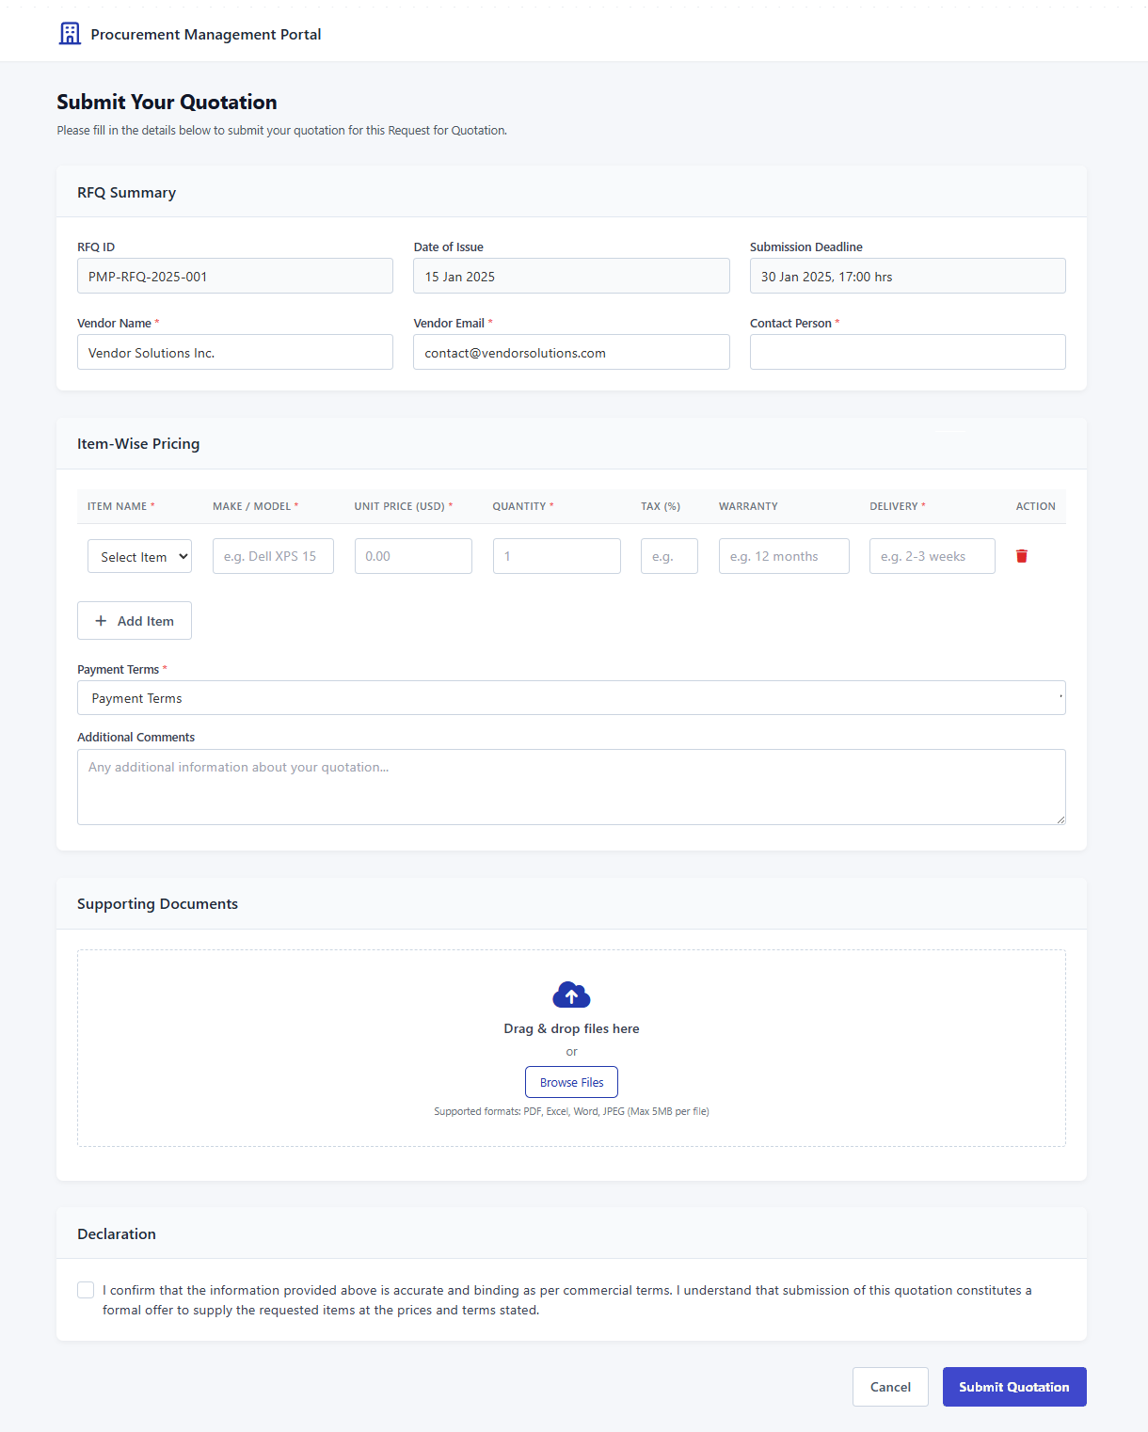

E04.3 View POs
- View vendor quotations received against each RFQ.
User Story Statement:
As a logged-in user from the Purchase Team,
I want to view previously created a POs from my dashboard,
so that I can track, review & revisit POs.
Acceptance Criteria:
- After a successful login, user is redirected to the dashboard.
- “All POs” tab displays a table for all previously issued POs with following details
  - PO No
  - Date
  - RFQ ID
  - Vendor Name
  - Total Price
  - “View PO” Button
  - “Download” Button
  - “Edit” if PO is saved as draft and not generated
- Table supports:
  - Search by PO No or Vendor
  - Filters (Status, Date Range)
  - Pagination for large datasets
- When user clicks “View PO” Button, PO opens in full details are shown
Validation Sheet:
Field Name | Data Type | Mandatory? | Editable? | Default Value | Validation Rules / Format | Max Length | Error Message | Remarks | Example Values
RFQ ID | Alpha-Numeric | Y | N | System generated | Auto-generated (UUID or sequence) | 20 | NA | Pulled from request | PMP-RQ-2025-001
Vendor Name | Text | Y | Y | NA | Valid company name | 100 | Please add a contact person |  | John Deer
Vendor Email | Alpha-Numeric with special char | Y | Y | purchase@abctech.com | Valid company email address | 100 | Please enter a valid email id | For further communication | enzo@abctech.com
Vendor Phone | Numeric | Y | Y | 111-7894561230 | Valid company phone no | 10 | Please enter a valid phone no | For further communication | +91 9876543210
PO No | Alpha-Numeric | Y | N | System generated | Auto-generated (UUID or sequence) | 20 | NA | Pulled from request | PO-ABC-2025-123456789
Date | Date | Y | Y | NA | System Date | NA | NA | Pulled from request | 19-06-2025
Delivery Location | Text | Y | N | NA | Text input, from dropdown | 50 | Select a delivery location | Submitted / Under Review / Shortlisted / Rejected | Regional Office, 5th Avenue, NYC
Sr. No. | Numeric | Y | N | Auto-filled | Numerical, auto-incremented | 100 | NA | NA | 1
Item Name | Text | Y | Y | NA | Text input | 300 |  |  | LG
Make / Model | Text | Y | Y | NA | Text input | 300 |  |  | UltraGerar 27GM
Quantity | Numerical | Y | Y | 1 | Numerical | 8 | Please enter a valid quantity |  | 10
Unit Price | Numerical | Y | Y | NA | Currency format | 8 | Please enter a valid quote price |  | 10
Total Price | Numerical | Y | Y | NA | Currency format | 8 | Please enter a valid quote price |  | 10
Delete row button | Action Buttons | Y | N | NA | NA | NA | NA | Deletes row
Add Item button | Action Buttons | Y | N | NA | NA | NA | NA | Adds a new row
Terms & Conditions | Text | Y | Y | NA | Text input | 300 | Please enter T&Cs |  | Payment 50% advance
Delivery Timeline | Text | Y | N | NA | Text input | 300 | Please enter delivery timeline |  | 3 weeks from PO Receipt
Additional Notes / Remarks /Instructions | Text | Y | N | NA | Text input | 300 | Please enter delivery timeline |  | Training costs extra
Attachments (JPEG/PNG/PDF/Excel/Word Files) | Attachment |  | N | NA |  |  |  | File preview/download link | TechSupply_Quote.pdf
Generate PO Button | Action Buttons | Y | N | NA | NA | NA | NA | Generates PO
Save as Draft Button | Action Buttons | Y | N | NA | NA | NA | NA | Saves form as draft
Cancel Button | Action Buttons | Y | N | NA | NA | NA | NA | Cancels PO Creation Process

Wireframes:
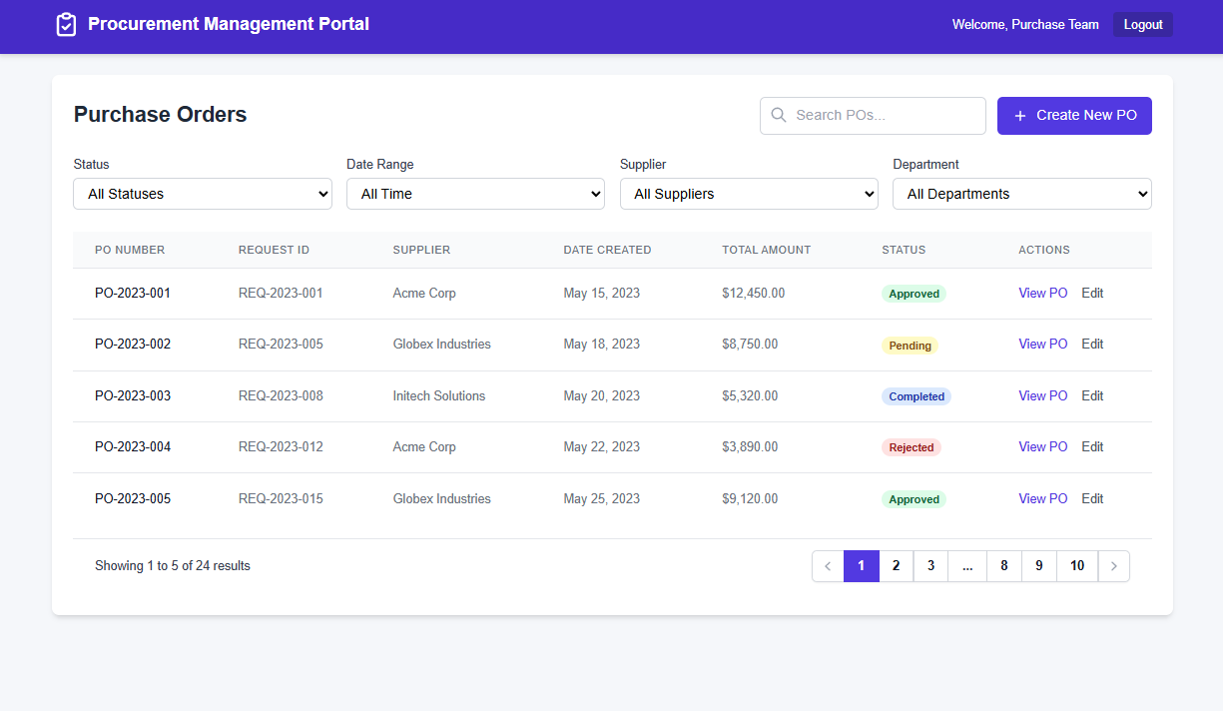

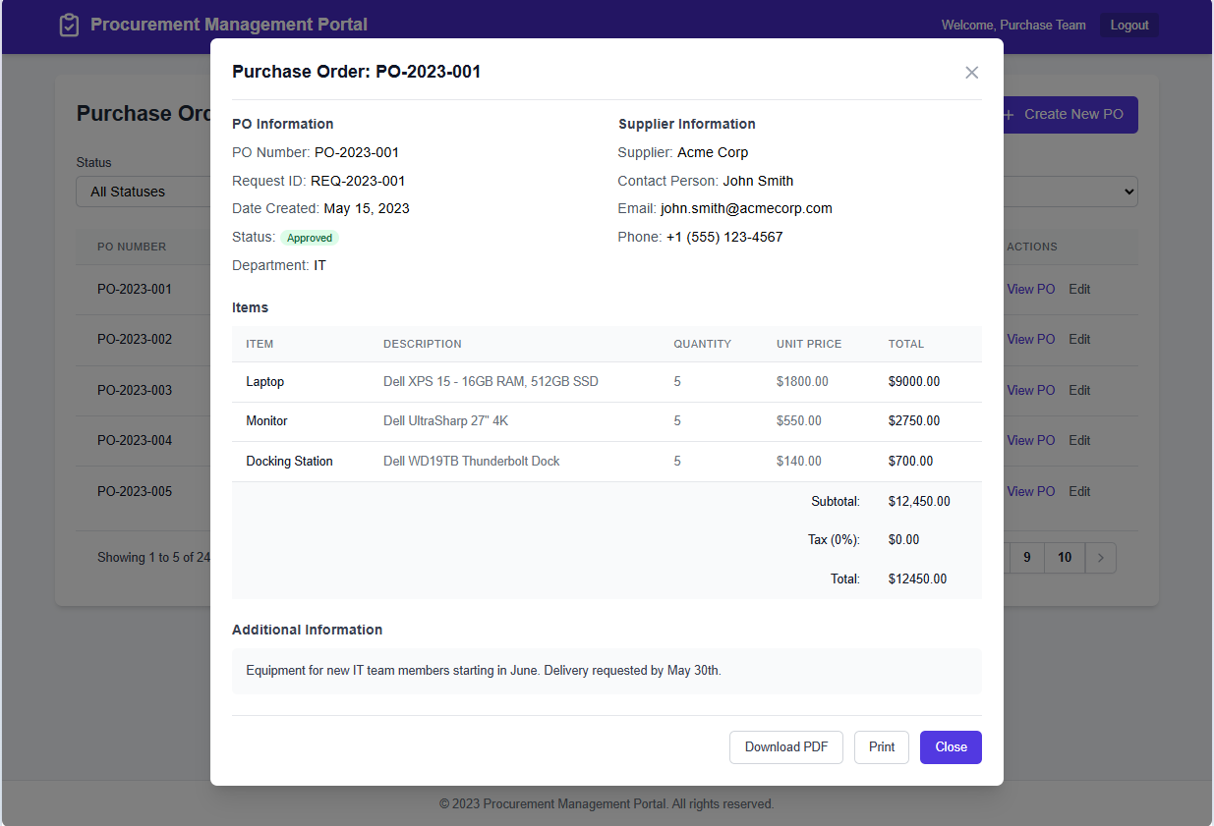

E04.3 Create and Send PO
- Generate and dispatch Purchase Orders based on selected quotes.
User Story Statement:
As a logged-in user from the Purchase Team,
I want to create a Purchase Order (PO) for the selected vendor from my dashboard,
so that I can formally initiate the procurement of hardware items.
Acceptance Criteria:
- After a successful login, user is redirected to the dashboard.
- A “Create PO” button is displayed and
- When user clicks it Create PO button, a form opens with following fields
  - PO Details
    - PO No
    - Date
    - RFQ ID
    - Vendor Name
    - Vendor Email
    - Vendor Phone
    - Delivery Location
  - Item Details Table
    - Sr. No.
    - Item name
    - Make / Model
    - Quantity
    - Unit Price
    - Total Price
  - Additional Fields
    - Delete row button
    - Add Item button
    - Terms & Conditions
    - Delivery Timeline
    - Additional Notes / Remarks /Instructions
    - Attachments (JPEG/PNG/PDF/Excel/Word Files)
  - Action Buttons
    - Generate PO Button
    - Save as Draft Button
    - Cancel Button
- Form validates the data as per the validation sheet attached and displays inline error message if any errors.
- When user clicks Generate PO Button,
  - PO is generated
  - Success message is displayed
“PO generated and sent successfully.”
  - A notification is sent to
    - Warehouse,
    - Accounts &
    - Vendor
  - Tally Prime is updated with PO details via API / Connector/ middleware.
  - System is updated & a copy is saved.
- If PO generation fails due to any error/network timeout, a message is displayed
“Something went wrong. Please try again.”
- If tally sync fails, a message is displayed
“Tally sync failed. Manual update & confirmation is advised!”
Validation Sheet
Field Name | Data Type | Mandatory? | Editable? | Default Value | Validation Rules / Format | Max Length | Error Message | Remarks | Example Values
RFQ ID | Alpha-Numeric | Y | N | System generated | Auto-generated (UUID or sequence) | 20 | NA | Pulled from request | PMP-RQ-2025-001
Vendor Name | Text | Y | Y | NA | Valid company name | 100 | Please add a contact person |  | John Deer
Vendor Email | Alpha-Numeric with special char | Y | Y | purchase@abctech.com | Valid company email address | 100 | Please enter a valid email id | For further communication | enzo@abctech.com
Vendor Phone | Numeric | Y | Y | 111-7894561230 | Valid company phone no | 10 | Please enter a valid phone no | For further communication | +91 9876543210
PO No | Alpha-Numeric | Y | N | System generated | Auto-generated (UUID or sequence) | 20 | NA | Pulled from request | PO-ABC-2025-123456789
Date | Date | Y | Y | NA | System Date | NA | NA | Pulled from request | 19-06-2025
Delivery Location | Text | Y | N | NA | Text input, from dropdown | 50 | Select a delivery location | Submitted / Under Review / Shortlisted / Rejected | Regional Office, 5th Avenue, NYC
Sr. No. | Numeric | Y | N | Auto-filled | Numerical, auto-incremented | 100 | NA | NA | 1
Item Name | Text | Y | Y | NA | Text input | 300 |  |  | LG
Make / Model | Text | Y | Y | NA | Text input | 300 |  |  | UltraGerar 27GM
Quantity | Numerical | Y | Y | 1 | Numerical | 8 | Please enter a valid quantity |  | 10
Unit Price | Numerical | Y | Y | NA | Currency format | 8 | Please enter a valid quote price |  | 10
Total Price | Numerical | Y | Y | NA | Currency format | 8 | Please enter a valid quote price |  | 10
Delete row button | Action Buttons | Y | N | NA | NA | NA | NA | Deletes row
Add Item button | Action Buttons | Y | N | NA | NA | NA | NA | Adds a new row
Terms & Conditions | Text | Y | Y | NA | Text input | 300 | Please enter T&Cs |  | Payment 50% advance
Delivery Timeline | Text | Y | N | NA | Text input | 300 | Please enter delivery timeline |  | 3 weeks from PO Receipt
Additional Notes / Remarks /Instructions | Text | Y | N | NA | Text input | 300 | Please enter delivery timeline |  | Training costs extra
Attachments (JPEG/PNG/PDF/Excel/Word Files) | Attachment |  | N | NA |  |  |  | File preview/download link | TechSupply_Quote.pdf
Generate PO Button | Action Buttons | Y | N | NA | NA | NA | NA | Generates PO
Save as Draft Button | Action Buttons | Y | N | NA | NA | NA | NA | Saves form as draft
Cancel Button | Action Buttons | Y | N | NA | NA | NA | NA | Cancels PO Creation Process

Wireframe: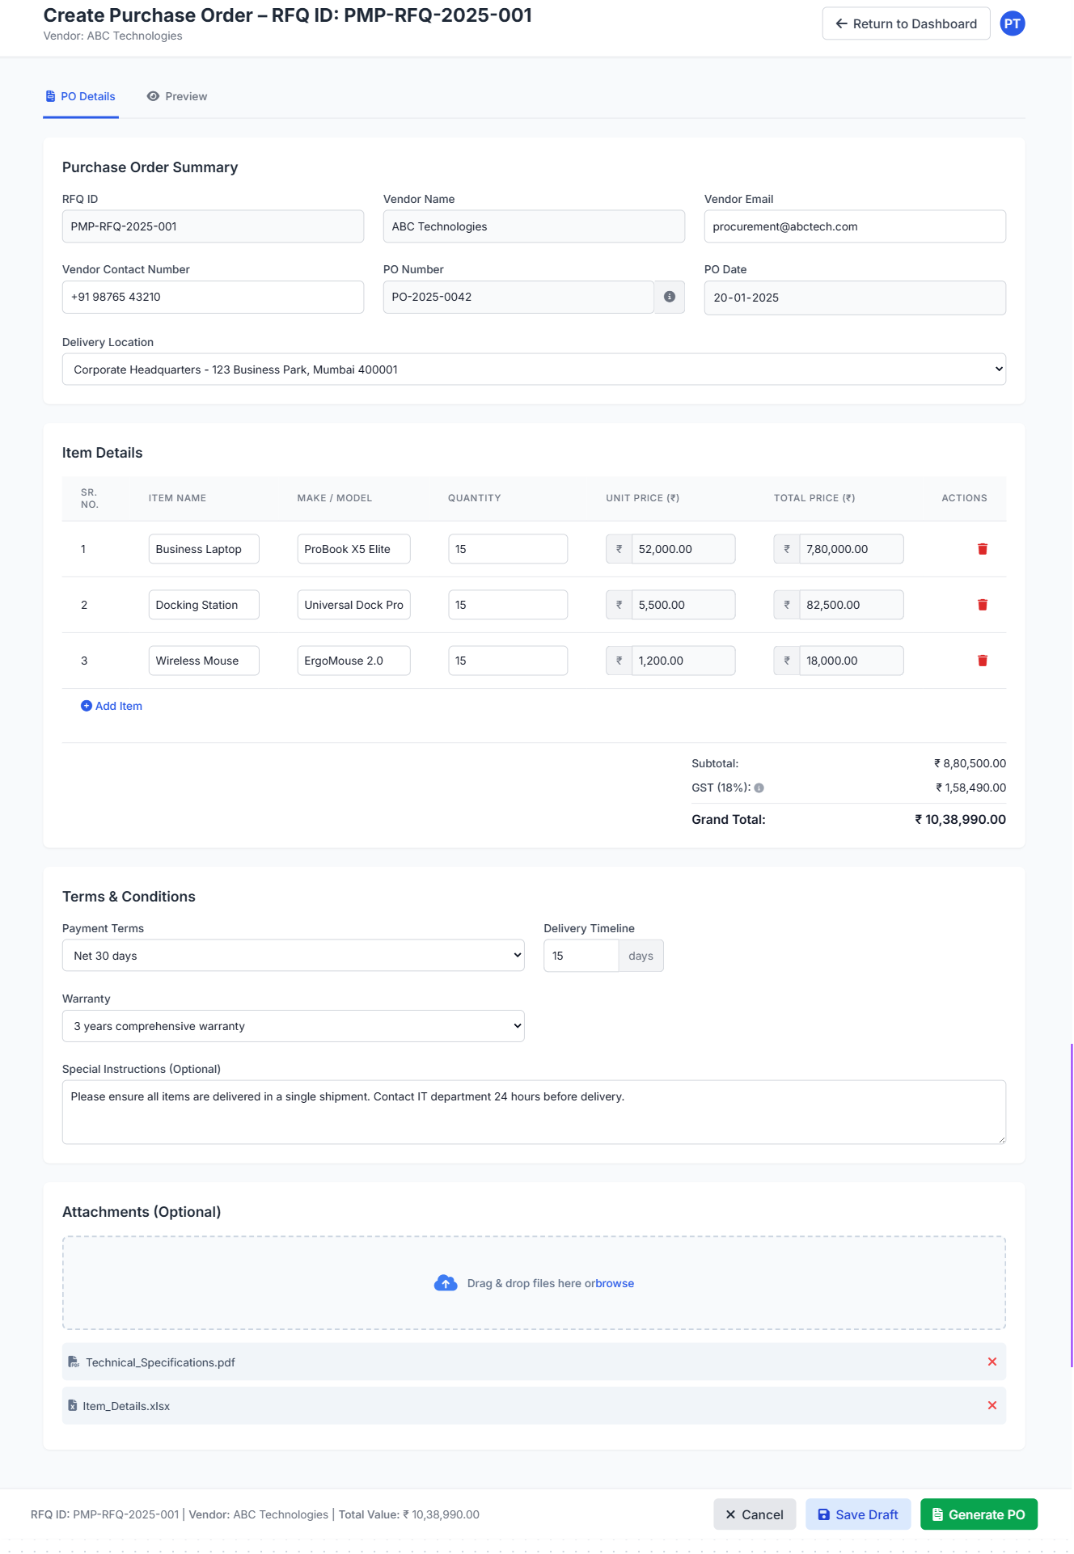

E05. Accounts Team Module

E05.1 3-Way Matching
User Story Statement:
As a logged-in user from the Accounts Team,
I want to view and compare PO, GRN & Invoice for an order from my dashboard,
so that I can verify whether all documents align before initiating vendor payment, or take action in case of a mismatch.
Acceptance Criteria:
- After a successful login, user is redirected to the dashboard.
- A “3 Way Matching” tab displays a table for all procurement requests fulfilled by the vendor and awaiting payment.
- Table displays following details side by side comparison for 3 Way Matching for PO, GRN & Invoice for each order for comparison
  - PO Number (for PO, GRN & Invoice)
  - Vendor Name (for PO, GRN & Invoice)
  - Item Name (for PO, GRN & Invoice)
  - Make/Model (for PO, GRN & Invoice)
  - Quantity (for PO, GRN & Invoice)
  - Unit Price (for PO & Invoice)
  - Tax/GST (for PO & Invoice)
  - Total Amount (for PO & Invoice)
  - Delivery Timeline (for PO & GRN)
Field | PO | GRN | Invoice | Remarks
PO Number | ✅ | ✅ | ✅ | Match Verified
Vendor Name | ✅ | ✅ | ✅ | Match Verified
Item Name | ✅ | ✅ | ✅ | Match Verified
Make/Model | ✅ | ✅ | ✅ | Match Verified
Quantity | ✅ | ✅ | ✅ | Match Verified
Unit Price | ✅ | NA | ✅ | Match Verified
Tax/GST | ✅ | NA | ✅ | Mismatch
Total Amount | ✅ | NA | ✅ | Mismatch
Delivery Timeline | ✅ | ✅ | NA | Match Verified

- The data is fetched from respective PO, GRN & Invoice linked by PO No.
- System compares the data and displays inline message as remarks
  - If all required fields match -> “Match verified”
  - If fields mismatch -> “Mismatch”
- User can add notes and remarks.
- Upon successful 3 Way Matching, when user clicks “Approve” Button
  - The vendor Invoice/PO/GRN is marked as “Ready for Payment”
  - A notification is sent to;
    - Vendor
    - Purchase Team
    - Warehouse Team

- When mismatches are observed, and user can click “Send Back for Verification” Button, then
  - The vendor Invoice/PO/GRN is marked as “Sent Back for Verification”
  - User can enter remarks
  - A notification is sent to;
    - Vendor
    - Purchase Team
    - Warehouse Team
- “View Document” button is available to preview PO, GRN & Invoice PDFs

Wireframes:
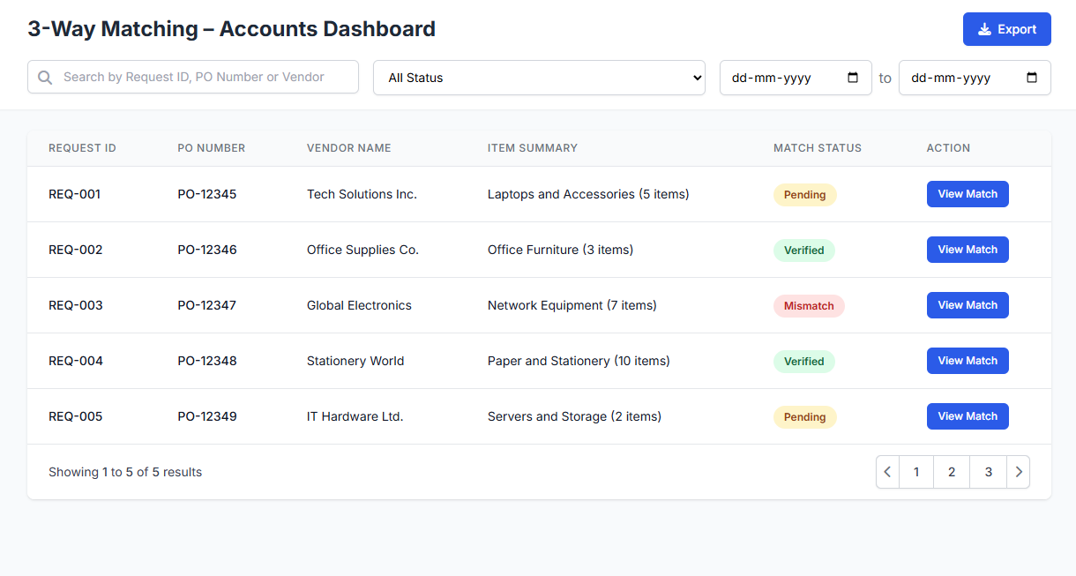
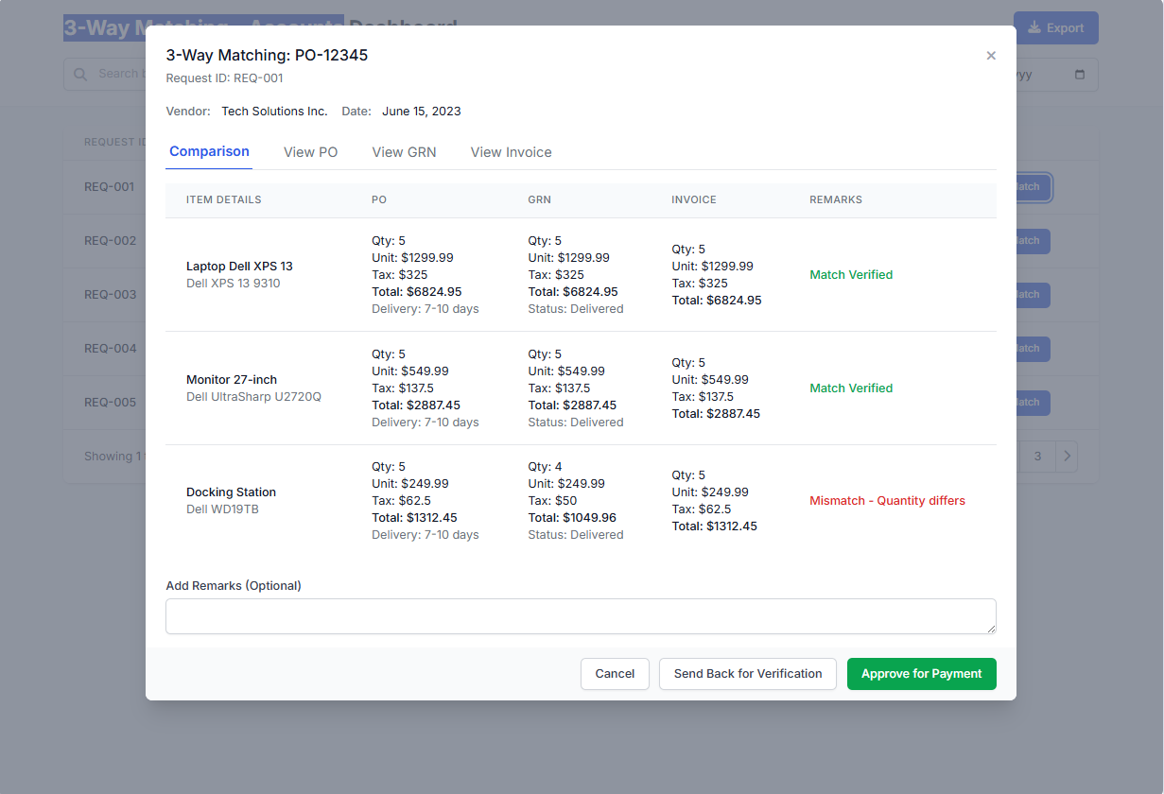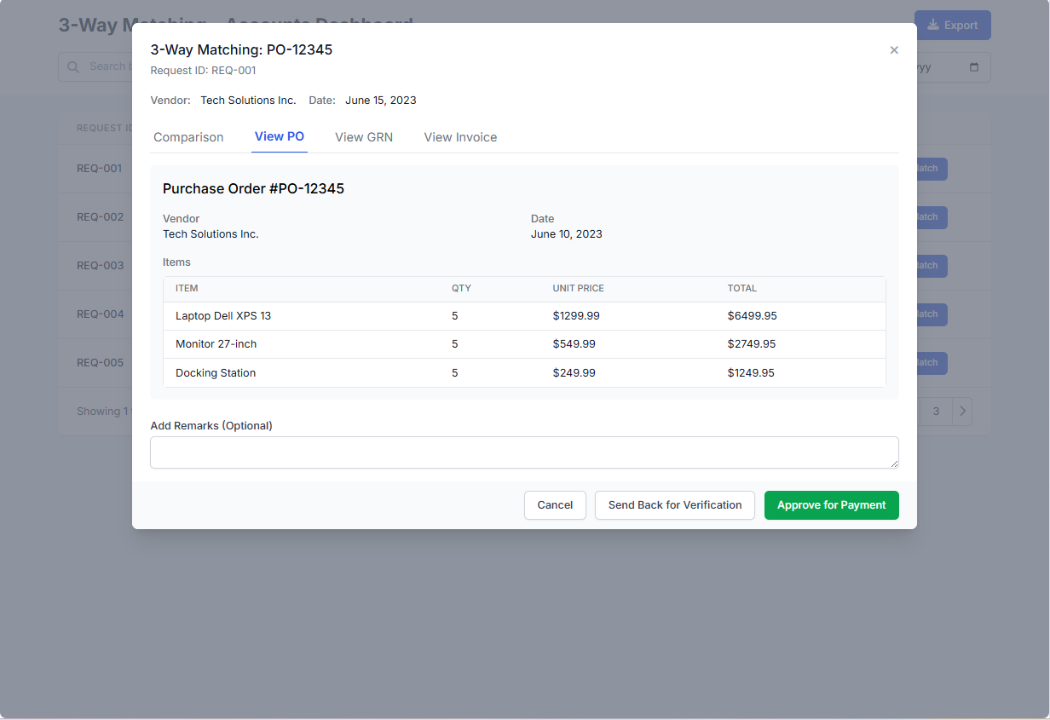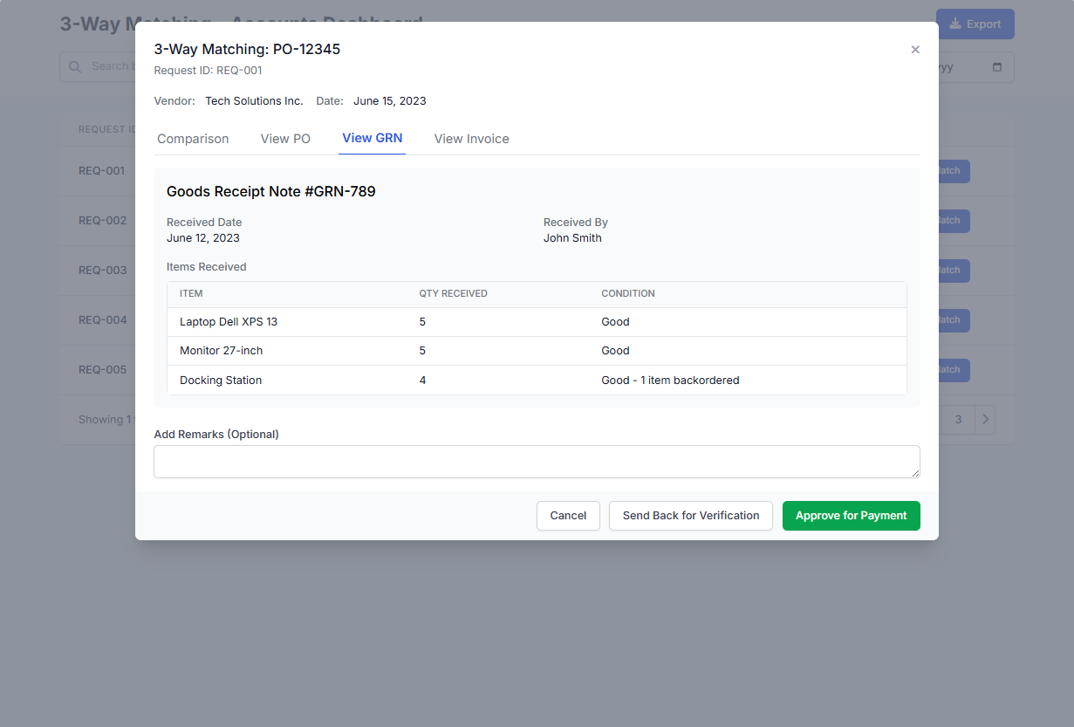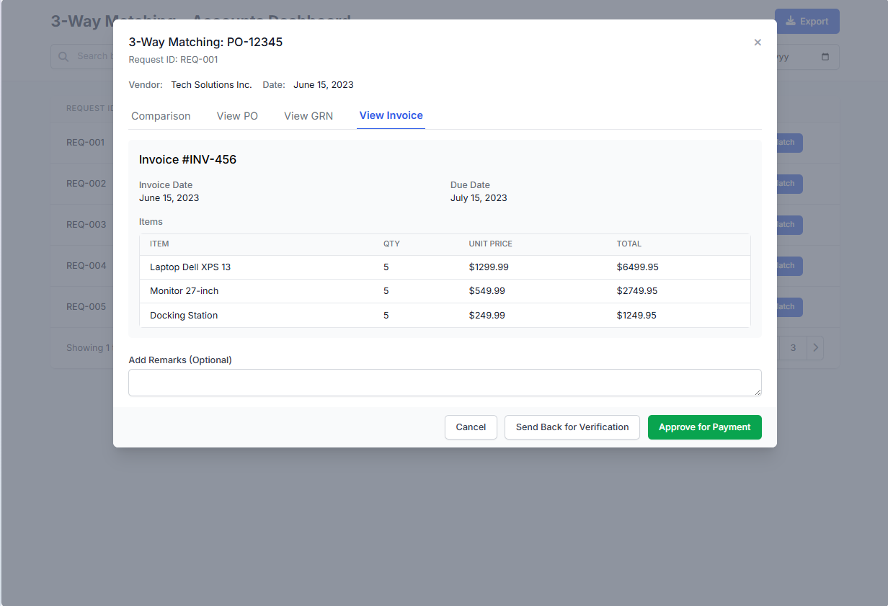

E05.2 Payment Status Update
User Story Statement:
As a logged-in user from the Accounts Team,
I want to update the payment status of procurement requests,
so all the concerned parties are informed and the procurement process is completed
Acceptance Criteria:
- After a successful login, user is redirected to the dashboard.
- A “Payments Status” tab displays a table for all procurement requests which have successfully passed the 3-way matching & are marked as “Ready for Payment“.
- The table should include the following columns:
  - PO No.
  - Vendor Name
  - Amount Payable
  - Invoice Date
  - Status (default: “Ready for Payment”)
  - Action buttons for View PO, View Invoice, View GRN
  - Action: “Update Payment Status”
- Upon successful completion of the payment to the vendor, the user can
  - Update the status of the Request as “Payment Completed” by clicking “Update Payment Status” button.
  - Upload proof of payment (PDF, Image format)
  - Save/Update changes.
- I case of any pending issues to be resolved before the payment to the vendor, the user can
  - Update the status of the Request as “Payment on Hold” by clicking “Update Payment Status” button.
  - Upload proof of payment (PDF, Image format) if applicable
  - Save/Update changes.
- Upon successful update/saving of changes by the user, a notification is sent to
  - Vendor
  - Purchase Team
- If file upload fails or required fields are missing, inline error messages are shown:
  - “Please upload valid payment proof.”
  - “Status update failed. Try again or contact IT.”

Validation Sheet
Field Name | Data Type | Mandatory? (Y/N) | Editable? (Y/N) | Default Value | Validation Rules / Format | Max Length | Error Message | Remarks | Example Values
PO Number | Alpha-Numeric | Y | N | Auto-filled | Pre-filled from system | 20 | NA | Pulled from 3-Way Match list | PO-ABC-2025-123
Vendor Name | Text | Y | N | Auto-filled | Alphanumeric | 100 | NA | From original procurement data | Tech Supply Pvt. Ltd.
Amount Payable | Currency | Y | N | Auto-filled | Numeric | 15 | NA | Calculated from PO/Invoice | ₹ 10,000
Invoice Date | Date | Y | N | Auto-filled | Valid system date | — | NA | From invoice metadata | 20-06-2025
Payment Status | Dropdown | Y | Y | “Ready for Payment” | Options: “Payment Completed”, “On Hold” | — | Please select a valid status | Controls workflow progression | Payment Completed
Upload Proof | File (PDF/Image) | Y (if completed) | Y | NA | PDF, PNG, JPG only; ≤ 5MB | — | Invalid file type/size | Optional for On Hold; Required for Completed | payment_receipt.pdf
Remarks | Text Area | N | Y | Blank | Alphanumeric + punctuation | 300 | “Please enter valid remarks (max 300 chars).” | Optional but helpful for audit or clarification | “Payment cleared via NEFT”

Wireframe:
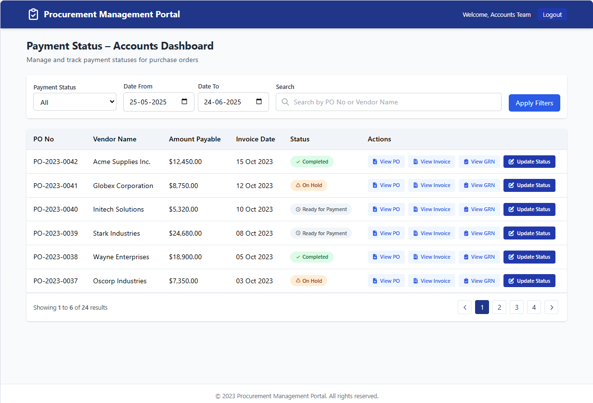

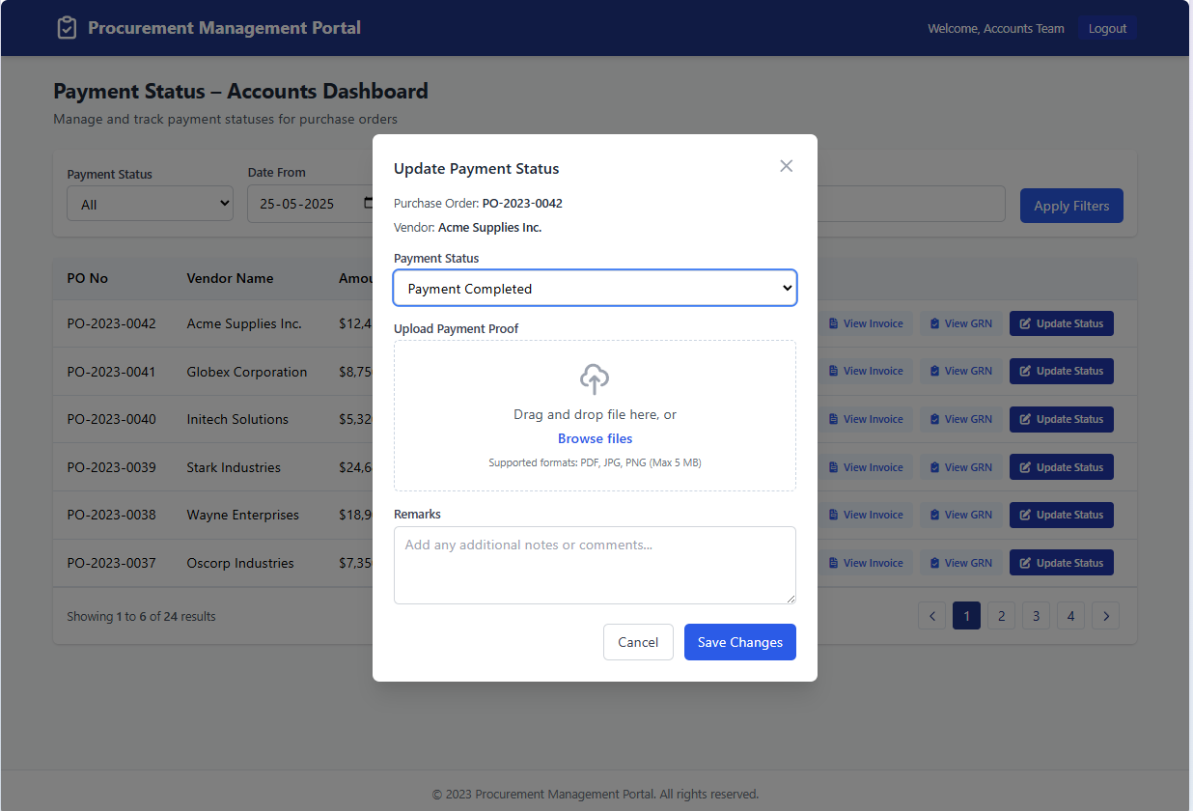

E06. System-Level Epics

US-E06.1a Generate Alerts & Notifications
User Story Statement:
As a system administrator,
I want the portal to automatically generate alerts and notifications upon defined system events,
so that users are kept informed about actions or changes related to their procurement requests.
Acceptance Criteria:
- System should trigger alerts for events like:
  - Request submission,
  - Request approval,
  - Warehouse to Purchase routing
  - GRN generation
  - PO generation
  - Vendor quote submission
  - 3-Way Matching Complete
  - Payment Status Update
- Types: Email + In-portal notifications
- Notifications sent to mapped roles only (Employee, Lead, Vendor, etc.)
- Errors (e.g., email failed) are logged and retried up to 3 times
- Notification generation is automated and timestamped

US-E06.1b View Alerts & Notifications (Portal)
User Story Statement:
As a logged-in user,
I want to view all my in-portal notifications in one place,
so that I can stay up to date with the procurement activities relevant to me.
Acceptance Criteria:
- Portal bell icon shows notification badge.
- Notification Center has two tabs: “Unread” and “All”
- Each notification includes:
  - Title (e.g., “Request Approved”)
  - Request ID
  - Short message
  - Timestamp
  - “View Request” button
- Actions:
  - Mark All as Read
  - Select multiple notifications to delete or mark read
- If no notifications: Show “You’re all caught up!”

E06.2 Role-Based Access Control (RBAC)
- Ensure users access only relevant screens and actions based on their role.
User Story Statement:
As a system administrator,
I want to enforce role-based access control within the Procurement Management Portal (PMP),
so that each user can only access features and perform actions permitted for their role.
Acceptance Criteria:
- Login Control:
  - Users must log in using unique credentials.
  - On login, system identifies user role (Employee, Lead, Manager, Purchase Team, Warehouse, Accounts, Admin, Vendor).
- Role-Based Dashboard Redirection:
  - Upon login, users are redirected to dashboards personalized for their role.
  - Example: Employees see their requests; Purchase team sees RFQs & POs; Accounts sees payment tabs.
- Screen Access Control:
  - Users can only view/operate modules assigned to their role.
  - Example:
    - All Employees → can only raise/view/cancel own requests.
    - Leads/Managers → Approve/Reject requests.
    - Purchase Team → can access RFQs, POs, vendor quotes.
    - Warehouse → can only access GRN and Inventory screens.
    - Vendor → can only access quote submission via tokenized links.
- Unauthorized Access Handling:
  - If a user tries to access a restricted screen:
    - A message is shown with an option to return to dashboard or contact support.
“Unauthorized – Access Denied!”
- Admin Role:
  - Full access to all modules.
  - Can manage users, roles, and override permissions in emergencies.
- Audit Trail:
  - All access attempts (valid and denied) are logged for security and auditing purposes.

- Role Matrix (Reference):
Role | Can View | Can Modify/Act On
Employee | Own Requests | Create, Modify, Cancel
Lead | Requests <= ₹5000 | Approve/Reject
Manager | Requests > ₹5000 | Approve/Reject
Warehouse | Requests, GRN | Fulfil, Create GRN
Purchase Team | RFQs, POs, Quotes | Issue RFQ, Compare, Issue PO
Accounts | PO, GRN, Invoices | 3-Way Match, Payment Update
Vendor (limited) | RFQ (via link) | Submit Quote
Admin | All | All

